In this photo taken June 3, 2014, the Elwha River flows into the Strait of Juan de Fuca near Port Angeles, Wash. 
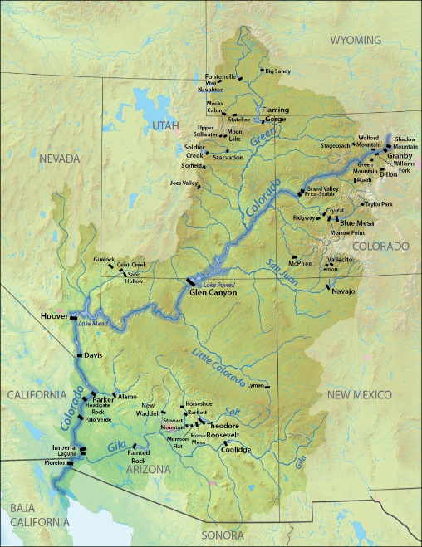The Colorado River stretches down one thousand four hundred and fifty miles. Across the Colorado River there are forty-four dams. These dams are capable of holding over seventy-seven million acre feet of water, and produce over four thousand five hundred Megawatts of power. For engineers, this is an amazing accomplishment of the old American West. They are able to provide millions of people with drinkable water, hydroelectric power and water for the irrigation of crops. With all of the accomplishments, come great costs. The dams cause slack water, which allows for sediment settling. They can become a breeding ground for disease, and they block fish from migrating to their original spawning grounds. The dams are causing great damage to the ecosystem.

1 Map of Colorado River with dam locations

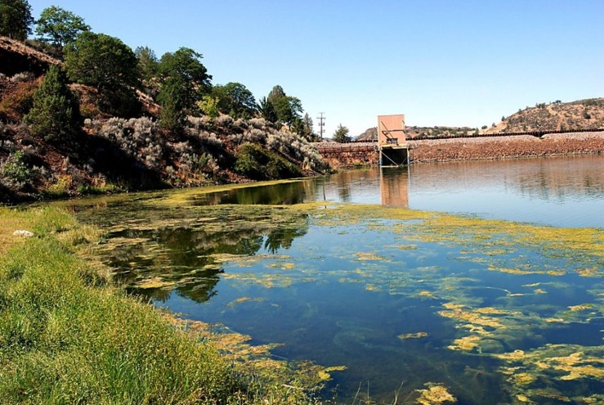 There are multiple different varieties of dams that have been engineered. The one standard that people envision when dams are mentioned, are blockage dams. This particular type is used to create a reservoir. According to the film Damnation, the reservoir then results in the settling of the sediment out of the water. This sediment is needed for the future existence of downstream ecosystems, including those that reach all the way to the ocean. “This prompts coastal erosion, as beaches are unable to replenish what waves erode without the sediment deposition of supporting river systems” (Morris 1998). Without the sedimentation, a river cannot maintain its riverbed. Eventually, the river cuts deeper into the ground and becomes narrower with steeper sidewalls.

2 The Elwha River flows into the Strait of Juan de Fuca, carrying sediment once trapped behind dams. The gradual release has rebuilt riverbanks and created estuary habitat for Dungeness crabs, clams, and other species.

Public health impact that is associated with reservoirs vary greatly. They fall into the categories of water-based and water-related diseases. These reservoirs formed by dams provide large areas of slack (stagnant) water ideal for parasites to breed and bacteria to grow. As most people from Idaho know, areas of stagnant water allow for a breeding ground for mosquitos. More than the fact that they are a nuisance, mosquitos can carry diseases, such as malaria, West Nile virus and yellow fever. Each disease can be very deadly to the human species. Escherichia coli (E. coli) and Clostridium tetani (tetanus) also grow in stagnant water. Both bacterium can also be toxic and deadly. “Also, dams provide a steady source of water, sustaining organisms that may have otherwise perished during the dry season” (Jobin 1999).

3 Algae in the reservoir behind Iron Gate Dam on the Klamath River near Hornbrook, California.

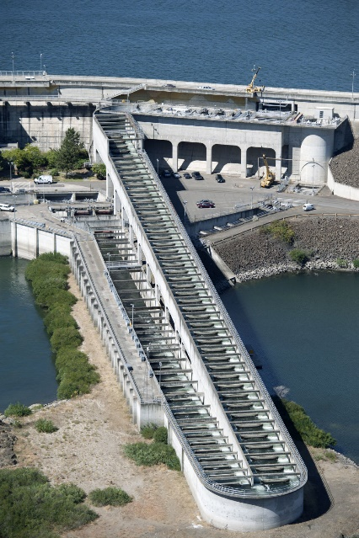The most important reason that dams are damaging to the ecosystem is they way they stop or dramatically slow the migration of future generations of fish. The fish are essential to the survival of many other types of animal. The animals included, but not limited to, are the bears and birds. The bears and the birds are seemingly the most effected by the dams. “The first effect of a dam is to alter the pattern of disturbances that the plants and animals of a river have evolved. Many aquatic animals coordinate their reproductive cycles with annual flood seasons” (Dynesius 1994). This ebb and flow of water is important to the overall ecological system surrounding a river or stream. For example, floods provide shallow backwater areas, far from the main river, a supply of water. The young of many animals depend on these backwaters to protect them from larger predators. A second example is a certain types of fish, like the catfish, lays their eggs in May when the amount of water that flows through the river is higher. The higher flow of water provides sustenance and protection from predators. If the river never runs at a higher than usual level the fish might take to laying eggs later in the year. Laying their eggs later in the ear may result in there not being enough food to survive.

4 Example of fish ladder

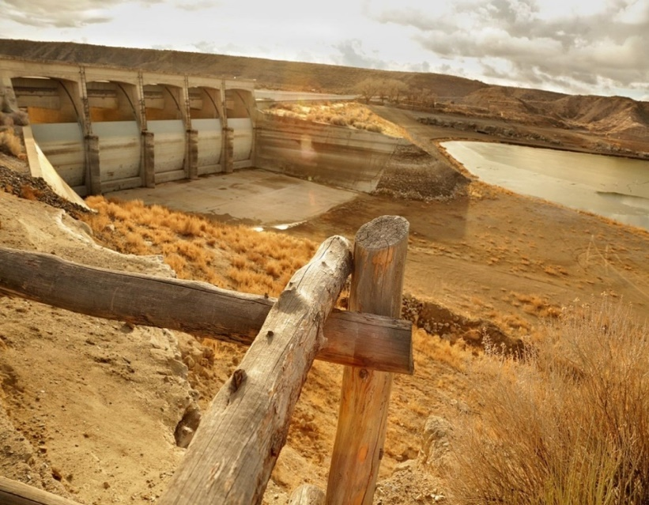Although dams are used for sustainable power, they are effective at stopping flooding and allow for successful water management, dams cause damage to the ecosystem they are put in. Most, if not all the damage that is caused by dams, is repairable with enough time. The sediment that is released after a dam is torn down is redeposited along the riverbed and all the way into the ocean to fix the beaches. With no large bodies of stagnant water, there is less of an incidence of water borne viruses to the public. With no large body of water behind the dam, other animals such as deer and elk would become more frequent in the area. Also without dams the fish population will grow back to amazing levels. With a higher level of fish population, it will attract other wildlife back to the area. The growth of the fish population, it would also allow the Native American tribes to fish more productively. I don’t believe that we could remove all dams from every river in the nation, but we should definitely look at every dam. It should be determined exactly what and how much it truly provides to the community. If it is at all possible to get rid of it without it causing problems to the community, like flooding and water management, then we should certainly remove it and allow the environment to heal itself. Our earth is the only one we have, and it should be well taken care of for the survival of our future.

5 The nearly depleted Rye Patch Reservoir, outside Lovelock, where the boat launch now stands 15 feet above the water

# Works Cited

Dynesius, M. and Nilsson C. 1994. "Fragmentation and Flow Regulation of River Systems in the Northern Third of the World." *Science* vol. 266 (5186): pp.753-762.

Jobin, W. 1999. *Dams and Disease.* London: E&FN Spoon.

Lin, Qicai. 2011. "Influence of Dams on River Ecosystem and Its Countermeasures." *Journal of Water Resource and Protection* (3): 60-66.

Morris, Gregory L. and Fan Jiahua. 1998. *Reservoir Sedimentation Handbook.* New York: McGraw-Hill Book Co.

2014. *Damnation.* Directed by Travis Rummel and Ben Knight.

# Images From

Figure 1: Photo by Shannon1 and used under Creative Commons license

https://commons.wikimedia.org/wiki/File:Colorado_river_dams.jpg

Figure 2: PHOTOGRAPH BY ELAINE THOMPSON, ASSOCIATED PRESS

http://news.nationalgeographic.com/news/2014/08/140826-elwha-river-dam-removal-salmon-science-olympic/

Figure 3: Taken by, Jeff Barnard for Associated Press

http://www.sfgate.com/science/article/Klamath-River-dam-removal-benefits-detailed-2308771.php

Figure 4: Photographed by HDR Inc.

http://www.hdrinc.com/portfolio/the-dalles-dam-fish-passage-improvements

Figure 5: Taken by, Tomo for Al Jazeera America

http://america.aljazeera.com/features/2014/2/drought-thinningtheherdofranchersinnevada0.html