Taylor Archuleta

Prof. Brooks

Hist 100

1 April 2016

Engineering Water Resources

There have been many different methods countries and cities have used to store and provide water for their citizens. Some countries have done a very good job about maximizing their resources. In the start of the early 1900’s the United States began building dams to store up water in rivers and control the amounts of water that is being distributed. One major dam that was built during this time was the Hoover Dam. Many people disapproved of building dams for belief that the ecosystem within those rivers will be destroyed. It has allowed us to be able to store water and save it, ever in case of a drought. This has proven to be effective especially in the water crisis that California and other states are experiencing. The building have such dams required large amounts of workers, many of those that were behind the designing of the structures knew of what great importance it would provide for present and later generations.

The Hoover dam was a major engineering feat during it’s time and still is considered an astonishing build to this day. It stands at 726 feet tall and helps control the flow of the Colorado River. During the depression, they began the building process of this monolithic project and it required thousands of workers, which many fled to the Black Canyon in search of work. It is known that about 21,000 men worked on the construction of the Hoover Dam, which is large number in human resources to have these men work daily to build this project. *Caption 1* shows the size of the city built to house all the new workers:

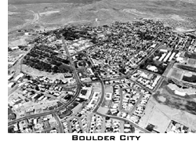

*Caption 1:* <http://www.arizona-leisure.com/hoover-dam-men.html>

This picture shows the number of houses and overview of how large this process truly was. The federal government used their land to help house the new workers. In this picture, it shows many of the houses, stores, and churches that were built for the public. This city is now known as Boulder City, Nevada.

Not only did it require lots of man power to build such a structure, but it also required a large amount of money which at the time our country was in an economic crisis also known as the “Great Depression”.

The damn was estimated to cost a total of about $49 million dollars. A lot of government money was put towards this goliath project that $49 million is estimated to be just about $750 million today. In *Caption 2* it is a cartoon that describes the American Power:



*Caption 2:* <http://www.economist.com/node/21533393>

I found this photo very intriguing to me because it describes how the federal government wanted to show the American people what they are capable of. The picture has Uncle Sam, which represents the American Government standing on the dam flexing and showing how strong the are. In the bottom left it shows an American Citizen looking upon Uncle Sam.

To me that photo speaks volume to what the Government was trying to accomplish during this time. There was lot of engineering and planning that went into this project. The dam was going to be able to control the distribution of the water in almost the entire southwest.

This dam has played a major factor in maximizing water resources. The Hoover Dam allowed the government to regulate the flow of the Colorado River, which is a major supplier of water to the southwest United States. The states that rely greatly on the flow of the Colorado River are the lower basin states, which are California, Nevada, and Arizona. Each of these states are fighting a water crisis and have controlled watering for their citizens. The Dam allows the government to control water flow through the river and make sure that enough water will be saved until the next melting of snow in the upper basin.

After the Dam was built it helped with the major development of major cities like Los Angeles and Las Vegas. These cities were able to get sustain water, and not only did the Dam provide water to these cities, it also provided electricity. The Dam ran major hydroelectric turbines that generated energy, as water would rush through them. The dam helps provide electricity to millions of homes along the lower basin. In *Caption 3* it shows a breakdown of how of a hydroelectric dam works:

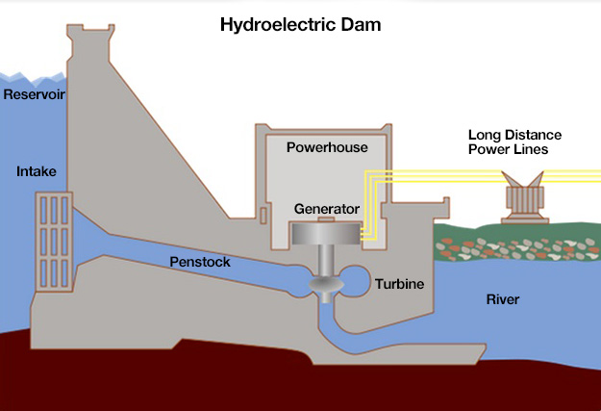

*Caption 3:* [*https://www.e-education.psu.edu/earth104/node/1067*](https://www.e-education.psu.edu/earth104/node/1067)

I found this diagram very informative it gives somebody a breakdown of how a hydroelectric dam work and how the water is controlled. There are gates that control the water flow through the penstock. Then the water is rushed through the turbines cause them to spin creating energy that can be stored and distributed through power lines to nearby plants and cities.

Not only does the dam help maximize the storage and dispersion of water, but at the same time is helping create electricity to provide for millions of people. That to me is the perfectly engineered structure that maximizes every ounce of the water resources that the Colorado River provides.

I feel as though the Hoover Dam has been a testament to an engineering masterpiece. Especially during the era, it was built. Our country was in a “Great Depression” money and jobs were difficult to find, but this building of the Hoover Dam created jobs and show other countries what the United States was capable to do. Major states and cities have been able to thrive off the resources that the dam provides. Water flow and disbursement can be controlled and managed. When the drought does “strike” cities will be able to survive and maintain normal life during a time of crisis.

Resources

Alley, R. B. (n.d.). Conventional Hydroelectric Dams. Retrieved April 08, 2016, from <https://www.e-education.psu.edu/earth104/node/1067>

Arizona Leisure. (n.d.). Hoover Dam. Retrieved April 08, 2016, from <http://www.arizona-leisure.com/hoover-dam-men.html>

The Economist. (2011). Revisiting the Hoover Dam. Retrieved April 08, 2016, from <http://www.economist.com/node/21533393>

US Department of Interior. (15, March 15). HOOVER DAM. Retrieved April 08, 2016, from <http://www.usbr.gov/lc/hooverdam/faqs/damfaqs.html>