Kyle Mitsunaga

Pictorial Essay

History 100

Changing Our Water Habits

We live in a world where the human population has been rapidly growing from “2.5 billion people in 1950, 6.5 billion in 2005, and projected to be 9 billion by 2050” (1). At that rate of human growth, an issue that must be addressed is water conservation. There are multiple ways to conserve water in our everyday lives. Brushing our teeth, broken sprinklers being ignored, taking long showers, etc. Our habits that we have today must change in order to steer away from the fear of running out of water period.

Brushing your teeth and leaving the water on, not all people do this but there’s still a large amount that does. According to an experiment “letting the water run while you are brushing your teeth can lead to more than 200 gallons of water wasted in a month” (2).

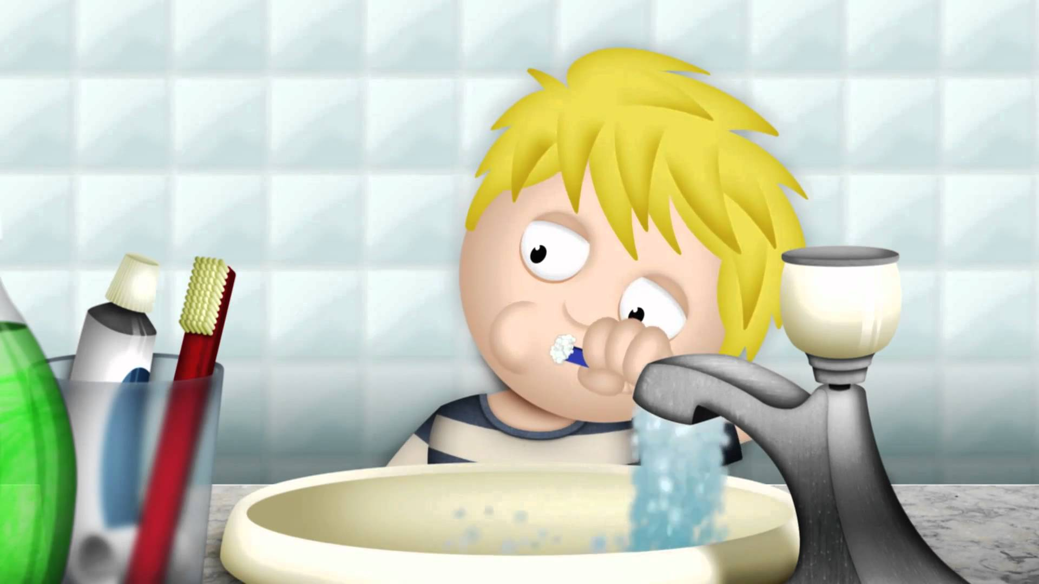 (3) 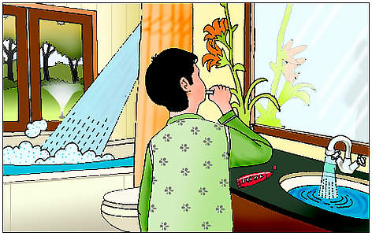

(8)

This picture, which seems like an innocent boy brushing his teeth, really is causing damage to our water supple by leaving the water on. It’s a simple concept but can be hard to break if it’s a habit. If humans can turn the faucet off for that little time period while brushing your teeth, it could save gallons and gallons of water like I said above.

According to a web data base a company based out of Britain is doing everything they can to allow people to be aware of how much water and time they spend in the shower. This company created a shower meter that shows in liters how much water is being used (4), and how long you’ve been singing your favorite songs in the shower. I really like what this company is trying to do. They are doing things in their power to bring attention to our water habits. I believe if all showers had these meters, it would be eye opening for a lot of people. (5)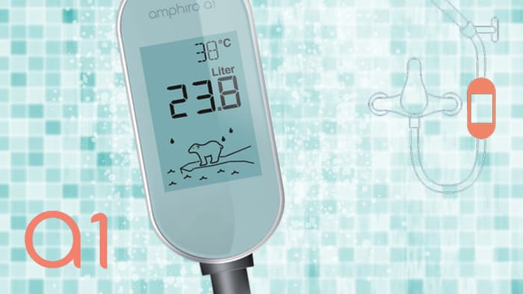

This is an example of what one of these devices looks like. Again it isn’t anything special, but if people can see how much water they are using in the shower it can lead us to more people saving more water.

(6)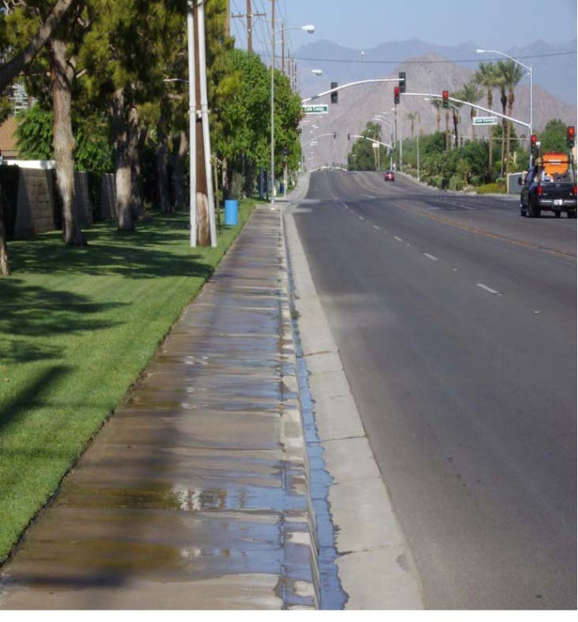

When you take a glance at this picture you may think it’s just a long never-ending road heading towards the mountains. Maybe you notice the palm trees or somehow think it is a gorgeous picture. This picture shows proof that people are wasting a large amount of water by broken sprinkler systems. Also people that don’t have the proper irrigation will add to this problem. According to hydroknot.com “a one-half inch sprinkler pipe will flow 13-16 per minute when broken” (7). This is a common problem that I see quite too often. A broken pipe at that size that isn’t fixed right away is wasting far too much water to be ignored. We’ve all seen it, walking to and from classes on campus, golf courses, parks, or in the neighborhoods. Our minds think of a broken sprinkler system or pipe as a nuisance and an expense. In reality it is hurting our future with the amount of water that is being wasted. Watering the concrete for instance in this picture does absolutely no good. A pipe that is broken and leaking, flooding the ground isn’t much better at all. It can be an easy fix if humans get on top of it right away. Not only are you fixing a problem with your landscaping and irrigation, but your also helping with the future and the push to conserve water in America.

(9)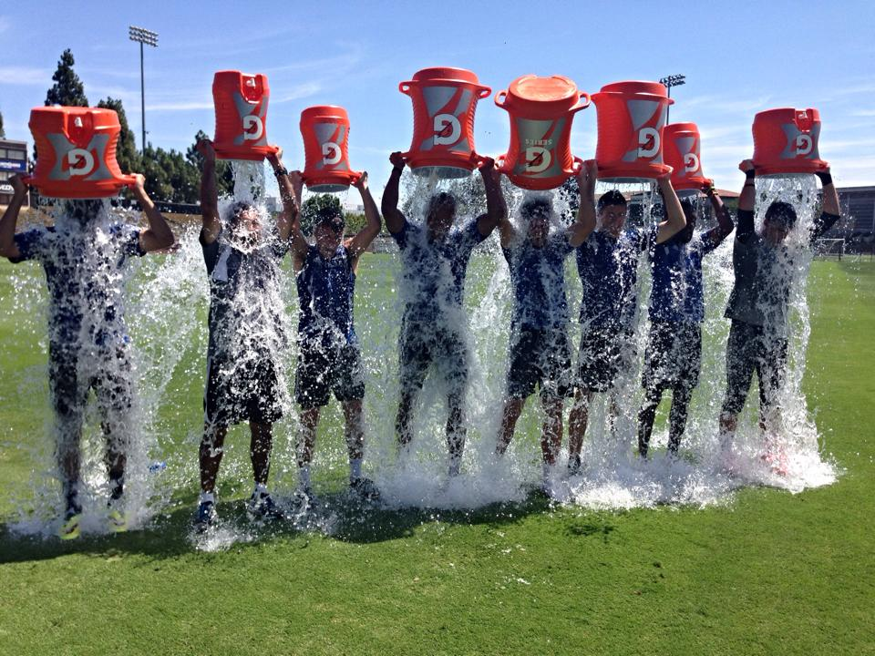

Here is a picture of a sports team participating in the ALS ice bucket challenge. This was a challenge that brought attention to ALS. All for a good cause, but on the other side of thing we ignore the fact that we have a water issue and people all around the country were participating in this challenge.

I’m not here to say I’m against this challenge. I think the picture above proves that most Americans can’t fathom that there is an issue with our water supply. A couple ideas arise, one people either are aware of the water issue but do not believe it is affecting them enough to change their habits of use. Secondly, people just flat out don’t realize that this issue is becoming reality. Even though it doesn’t seem like these people in this challenge are wasting that much water, just think about how many millions of people participated in this challenge that went viral over the last couple years.

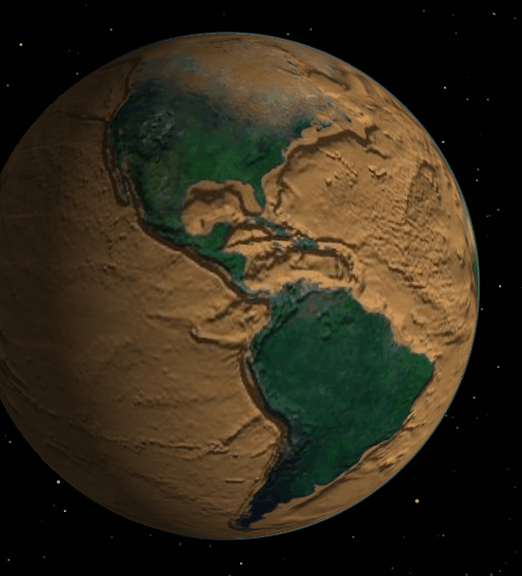(10)

(11)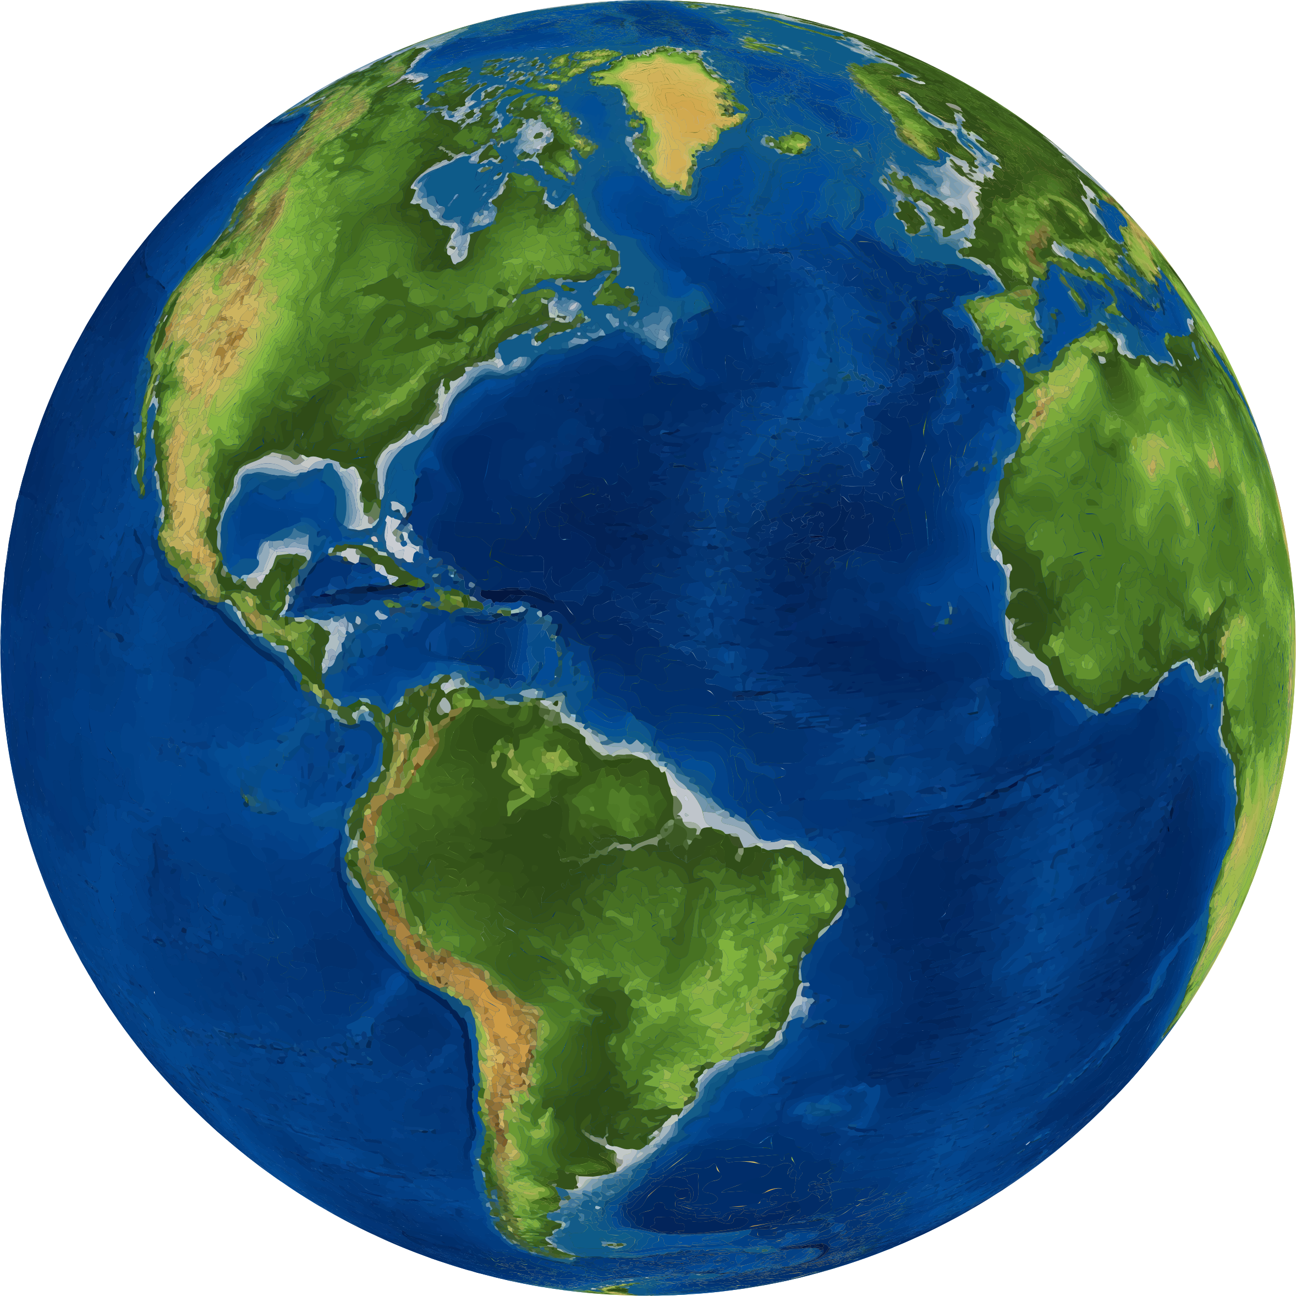

Even though it doesn’t seem likely that changing our individual water use habits would make a change for the better, it would. If people start a trend that and pass bills that enforce people to update faulty irrigation, and people start changing their habits with how much water we waste on a daily basis we would be doing ourselves a favor. Yes, running out of water may not happen in our lifetime. But we certainly want the best for our children’s future and it starts with the simple changes in our own lives. With these changes comes the bigger picture where California is no longer in a drought for water. Baby steps leads to the ultimate goal of conserving water for all. In the end would we want Mother Earth to look dry and dull like the first of these two pictures? Or do we want to see Mother Earth as we were brought into life filled with water, which is the second of the two pictures? It starts with us to keep earth looking healthy because in the end we would be doing ourselves the favor and no body else.

Endnotes

1.[http://www.prb.org/Publications/LessonPlans/HumanPopulation/PopulationGrowth.aspx](http://www.prb.org/Publications/Lesson-Plans/HumanPopulation/PopulationGrowth.aspx)

2. <http://brushteethnow.com/how-much-water-wasted-brushing-teeth.html>

3. <https://www.youtube.com/watch?v=pr3-I68c-GE>

4.<http://www.lexisnexis.com.libproxy.boisestate.edu/hottopics/lnacademic/?shr=t&csi=6742&sr=HLEAD(%22A%20Shower%20Meter%20That%20Measures%20Water%20Use%20While%20You%20Sing%20and%20Scrub.%22)%20and%20date%20is%202008>

5. <http://img-2.gizmag.com/amphiro-a1-water-meter.jpg?auto=format%2Ccompress&ch=Width%2CDPR&crop=entropy&fit=crop&h=394&q=60&w=700&s=75c1ac790347fe172518285551b46f66>

6. <http://www.indio.org/Modules/ShowImage.aspx?imageid=279>

7. <http://www.hydroknot.com/water-facts/>

8. <http://d2ouvy59p0dg6k.cloudfront.net/img/wasting_water_large_350396.jpg>

9. <https://cbslive105.files.wordpress.com/2014/08/quakes-bucket.jpg>

10. <https://software.grok.lsu.edu/Image/16271.gif>

11. <https://openclipart.org/image/2400px/svg_to_png/218125/3d-Earth-Globe.png>