Aquifers around the United States hold great importance in regards to water use and management from state to state. There have been 70 major aquifers identified in the state of Idaho, though by the definition required for an aquifer to be identified it would seem as though Idaho would have a sufficient water supply, though the underground sources are being depleted (1).

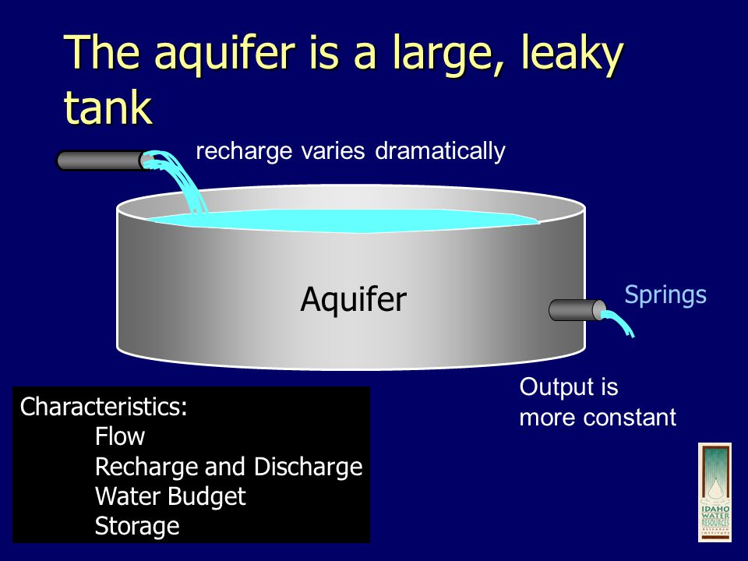

An aquifer is where large quantities of water come together to fill the spaces in the rocks and sediment of the ground (1). There are specific properties that said area would need to contain for it to be considered and aquifer in the state of Idaho. Specifically it needs to produce and give economically significant amounts of water to surrounding springs and wells (1). They are also categorized based on the sustainability of the surround earth, vulnerability of the ground water within the aquifer, as well as social and economic factors such as the urbanization of a particular area.

The image below shows the three major types of aquifers in Idaho, and by color shows were those aquifers lay across the state of Idaho. The different type of aquifer effects the availability of the Water, the flow of the water, as well as the amount of water in each aquifer (4)(1).

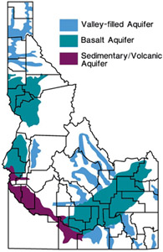

A valley fill aquifer pictured above in the blue color is an aquifer that the flow of water is not blocked going into the aquifer. The rock and sediment of the aquifer are so loosely fitted together in these regions that the flow of water moves freely. Because of the loose fit in these specific aquifers, the water moves at much more rapid rates than other areas.

Basaltic rocks are the characteristic of basalt aquifers. In the image above pictured in the turquoise color. This region is also the Snake River Plain aquifer. Basaltic rock is from volcanic activity in the past. This rocks makes for a strong aquifer base because of the gaps and spaces the rock and volcanic activity created.

Sedimentary aquifers are characterized by basic bedrock, clay, loose gravel, sands and silts. These aquifers also have basalt and similar rock mixed in which creates a more solid structure than the sand and gravel alone. This area of the map pictured in a purple color. Most familiar with the geography of Idaho could recognize that this part of Idaho is relatively all desert, lacking as much volcanic rock as the area the Snake River Plain aquifer is located in (6).

The ground water in aquifers can be compared to the money in a bank account. Though water can be added back, or put aside for later use (saved), there is the potential for it to be completely depleted. Ground water from aquifers across the United States gives drinking water to half of the urban population and primarily all of the rural populations (2).

The image is a great representation of how the agriculture of Idaho has the greatest affect on the aquifers, especially in the southern parts of Idaho, with more desert plains for the agriculture to be facilitated on.

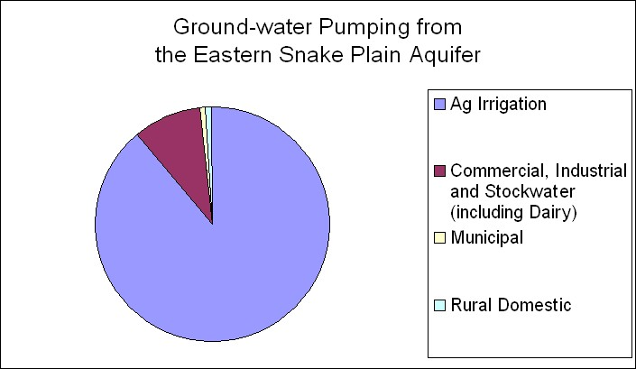

One of the larger aquifers in Idaho is the Snake River Plain Aquifer picture below. Not only is it the largest in the state of Idaho but also one of the largest in the world, it is also one of the most productive aquifers.

At a point in the 1970’s the Snake River Plain was recharged as the irrigation waters were seeping back into the ground thus into the aquifer. The biggest problem we are facing in the recharge of the aquifers is the increase in agriculture thus an increase in the use of water. Similar to your bank account as mention above, the water is moving out of the aquifer faster then it can be recharged. Another issue that is growing as we as a society are growing our technology is that of technology for efficient water use. Obviously that in its self is important, but after the aquifer was recharged in the 70’s, and technology started to flourish the use of water efficient sprinkler systems limited the return of water back into the aquifer (5).

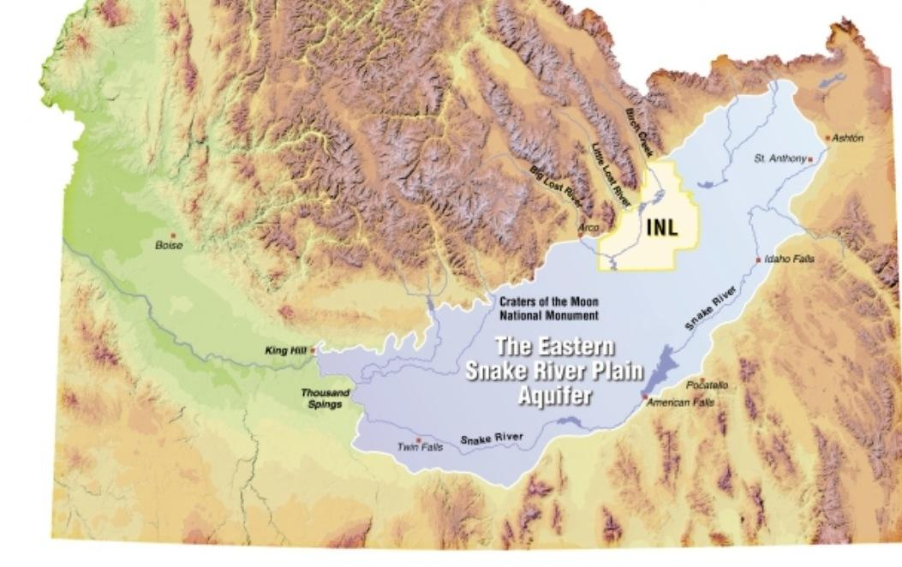

Careful planning and management of all of the aquifers in the State of Idaho, as well as all of the States is important to not have to shut off the aquifer entirely until it has recharged to sustainable amounts once again. As of now counties and cities have specific rights to usage of specific aquifers across the state. One important aspect of managing the aquifers is to not allow one user to demand the entire use of a specific aquifer.

Active management of the aquifers could sustain us through droughts, and not allow the droughts to dictate the use of the aquifers in that year. We are also running into the problem of senior water rights where people or counties or cities own the rights to specific amounts of water, or the usage of water from specific aquifers. Would it be fair to force the buy back of water rights, so that they can be evenly distributed for the entire economy? Since Idaho still follows the “first in time, first in right” law to appropriate the usage of the aquifer and facilitate those waters (4, 5 ,6).

Though the implications of management have a threat against the industries that use most of the water. For Idaho the farmers in the southern region have the potential to face the worst of the effects of the potential management. In recent years the farmers were threatened by their rights of pumping directly from the Snake River Plains aquifer being taken from them. Leaving them and their farms at risk.

1) "Department Of Environmental Quality." Aquifers. Accessed April 02, 2016. https://www.deq.idaho.gov/water-quality/ground-water/aquifers/.

2) " Ground-Water Depletion across the Nation" Accessed April 02, 2016. http://pubs.usgs.gov/fs/fs-103-03/.

3) "Idaho Needs a Comprehensive Aquifer Management Plan." <http://magicvalley.com/news/opinion/editorial/reader-comments/idaho-needs-a-comprehensive-aquifer-management-plan/article_8a45da71-fe18-588f-9fe3-d7fc4e65d28c.html>.

4) **"Department Of Environmental Quality." Sole Source Aquifers. Accessed April 02, 2016. https://www.deq.idaho.gov/water-quality/ground-water/sole-source-aquifers/.**

5) **"A New Report Says We're Draining Our Aquifers Faster than Ever." (Dry News from the Water Mines). 2013. Accessed April 02, 2016.** [**https://www.hcn.org/issues/45.12/a-new-report-says-were-draining-our-aquifers-faster-than-ever**](https://www.hcn.org/issues/45.12/a-new-report-says-were-draining-our-aquifers-faster-than-ever)**.**

**6)http://legislature.idaho.gov/sessioninfo/2014/interim/resources0917_tuthill2.pdf**

IMAGES

<http://www.idahogeology.org/Services/Hydrogeology/Idaho_aquifiers2.jpg>

<http://mediad.publicbroadcasting.net/p/idaho/files/styles/x_large/public/201501/snake_aquifer.jpg>

<http://slideplayer.com/slide/5085651/>

<http://images.slideplayer.com/16/5085651/slides/slide_3.jpg>