**Early Filtration Methods in the American West**

With less than 1% of Earth’s water being drinkable, water treatment is necessary to sustain life. The water we drink needs to be clean and purified in order to prevent the spread of diseases and harmful bacteria into our systems. There are several methods to purifying water that have developed, each with their own distinct advantages and disadvantages. For the purpose of cost, ability to produce on a large scale, and overall cleanliness while still maintaining taste, the method of microporous basic filtration (sand filtration) has stood the test of time as the first large-scale method of water filtration, and is the best method of purification used in the American West today.

Ancient writings have revealed that people have been purifying water as early as 2000 B.C., long before any such system was implemented in the American West. The means used to purify water in the earliest times were heat, whether it is by boiling water, the sun, or dipping heated iron into it. The first article on public hygiene was written by Hippocrates between 460-377 B.C., and he stated that water could have different taste and quality, and invented the Hippocrates sleeve, a bag system that caught sediments in water. The Middle Ages, also known as the Dark Ages, presented little advancement in water technology. It was in France in 1746 that Joseph Amy patented the first water filter to be placed on the market. The most common filtering materials during this time were wool, sponge, and sand. The first filter used for citywide supply came about in Scotland in 1804, a sand filter system developed by John Gibbs.

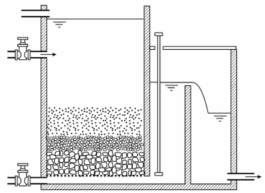

Basic design of a sand filter system.

The United States entered the water filtration industry a bit later, making its debut in Richmond, Virginia in 1832. Filters of gravel and sand were positioned in the James River, but the trial was a fail due to the high turbulence of the river. It was in 1872 that the first successful filtration of public drinking water occurred, through a process called slow sand filtration. It was not a new concept, but was used for the first time on a large scale in Poughkeepsie, N.Y. The problem with sand filtration was its inefficiency; at 3 million gallons per acre, a lot of land was required to sustain large cities. Several cities in the New England area adopted the technique by 1900.

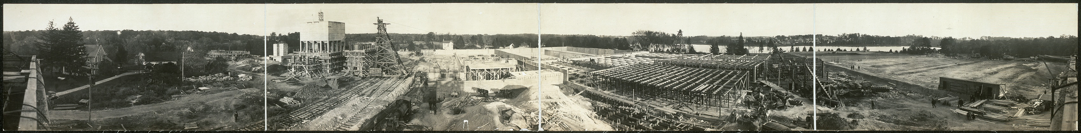

A panoramic view of a water treatment plant in Montabello, Baltimore in 1914 shows the land, facility and labor needed to maintain clean water for the community.

Around 1881, trials for coagulation were being performed. The first successful treatment was by George Fuller. This method proved most useful preceding filtration, in order to get the cleanest possible water. Alan Hazen of Pittsburgh was simultaneously working on similar projects, and found the bacterial rate in coagulated water to be 97-99% less than non-coagulated water.

By World War II, sand filtration began to improve in order to maximize output. They began putting a layer of anthracite over a layer of fine sand, which helped catch larger particles that usually got caught deeper in the bed, increasing filtration flow length. Methods of sand filtration continued to improve as the years went on. The problem with the anthracite was that it sometimes added a strange taste and odor to the water. Virginia and West Virginia were among the first to add granular activated carbon (GAC) to their filtration systems, which remedied this odor and taste issue.

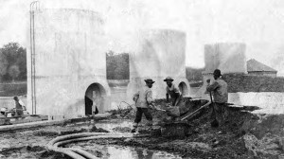

The McMillan Sand Filtration Site under construction in 1902. This was Washington DC’s first large-scale filtration sight, and occupied twenty-five acres.

Today, there are six methods used to purify water: distillation, ion exchange, carbon absorption, microporous basic filtration, reverse osmosis, and ultraviolet radiation.

The first process listed is distillation, which entails boiling water, and collecting a removing the vapor containing contaminants. While distillation removes the broadest range of contaminants, it fails to remove contaminants such as pesticides or herbicides, which require temperatures of up to 100 degrees Celsius in order to remove. It is also slower than other methods, more costly, and the water produced lacks oxygen and minerals, giving it a flat taste.

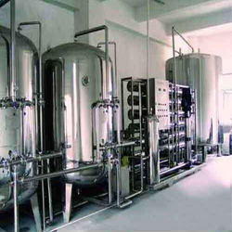

Although distillation removes a wide range of contaminants, the method is costly.

Next is the method of ion exchange. In this process, water is passed through ion-exchange resins. The process is excellent for removing inorganic materials; it is also relatively inexpensive. But, the ion resins do not remove bacteria, particles, or pyroxenes. The deionization beds can actually aid in the growth of bacteria. And, in the long run, cost of operating such systems is high.

The third option in purification is carbon absorption. This is a common at-home method, and is excellent for chemicals, gases, and some microorganisms. Most people use this method to rid their tap water of the chlorine taste. However, carbon removal does not rid water of dissolved solids or metals. It can also generate carbon fines.

Then comes the method of microporous basic filtration. There are three means by which this is done: depth, screen, and surface. Depth filters are matted and compressed, and catch debris randomly. Screen filters use pore size to catch particles. Surface filters contain multiple layers of material. These methods remove most particles, microorganisms, and colloids, are the most cost effective, and still produce high quality water. The one real disadvantage here is that this method of filtration will not remove dissolved inorganic material.

Reverse osmosis is the most economical method of filtration, and removes over 90% of contaminants. Water is forced using hydraulic pressure through a semipermeable membrane. Virtually all dissolved material is retained and removed from the water. The systems are generally easy to maintain. The problem with reverse osmosis is that flow rates are generally limited, and only a certain amount of gallons per day can be filtered.

Finally, there is the method of ultraviolet radiation. This method includes using mercury low-pressure lights over water. Protein and DNA in the water absorb UV light, inactivating microorganisms. The benefits are an excellent means of sanitizing water, and oxidation of organic compounds, but the method does not remove particles, colloids, or ions. 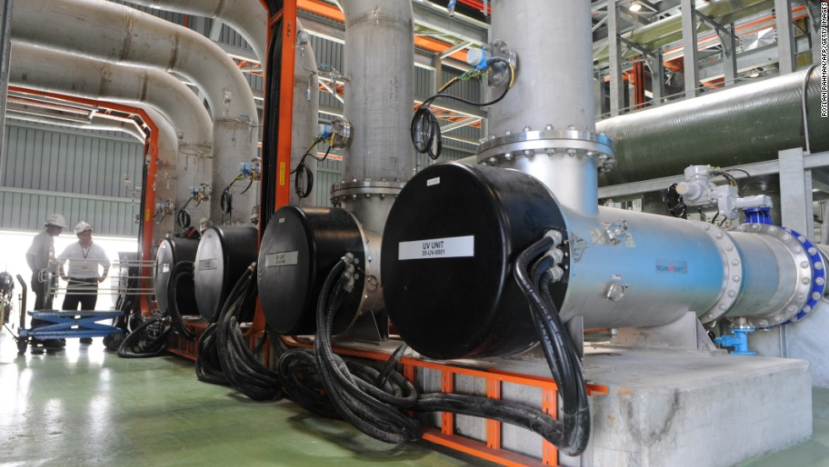

UV sanitation systems are much like tanning beds for water.

Although reverse osmosis is one of the best methods for removing material and cost efficiency, microporous basic filtration remains the best method of filtration to sustain large-scale populations such as cities. Filtration can be produced on a very large scale with no limit to the water ran through each day. It can be paired with other method of purification to improve its quality, but stands alone as sufficient purification with the only real limitation being the size of the bed through which you are send the water. The idea of filtration has remained tried and true since its introduction in 1804, and methods of filtration have only continued to improve from there.

References

1. Bruni, Marco A., and Dorothee Spuhler. "Slow Sand Filtration." Slow Sand Filtration. Accessed April 02, 2016. http://www.sswm.info/category/implementation-tools/water-purification/hardware/semi-centralised-drinking-water-treatmen-2.
2. Logsdon, G. S., M. Horsley, S. D. N. Freeman, J. J. Neemann, and G. C. Budd. 2006. "Filtration processes-A distinguished history and a promising future". *JOURNAL- AMERICAN WATER WORKS ASSOCIATION.*98 (3): 150-162.
3. "Drinking Water Laws and New Rules." Drinking Water Laws and New Rules. Accessed April 02, 2016. https://www3.epa.gov/region1/eco/drinkwater/laws_regs.html.
4. Mays L.W. 2013. "A brief history of water filtration/sedimentation". *Water Science and Technology: Water Supply.*13 (3): 735-742.
5. "Different Water Filtration Methods Explained." Different Water Filtration Methods. Accessed April 02, 2016. http://www.freedrinkingwater.com/water-education/quality-water-filtration-method.htm.
6. Mueller, Frederick W. 1914. *Water filtration plant at Montabello, Baltimore, Md*. Panoramic Photographs (Library of Congress).
7. Parsons, Thad. "BSHS Travel Guide." BSHS Travel Guide. March 22, 2012. Accessed April 02, 2016. http://www.bshs.org.uk/travel-guide/mcmillan-sand-filtration-site-washington-d-c.
8. Senthilingam, Meera. "Drinking Sewage: Solving Singapore's Water Problem." CNN. September 23, 2014. Accessed April 02, 2016. http://www.cnn.com/2014/09/23/living/newater-singapore/.
9. "Water Distillation Plant." - Water Purification Plants Exporter from Ahmedabad. Accessed April 02, 2016. http://www.watertreatmentsindia.com/water-distillation-plant.html#water-distillation-plant.