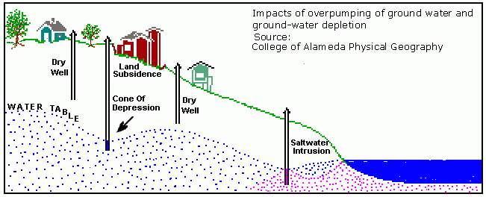
Water is essential to all biological life on earth and plays vital roles in sustaining earth’s hydrologic cycle. The use of water and its management by mankind has affected how we live, travel, transport, and gives us the ability to live our everyday lives. Fresh water is the key to survival for all living organisms on our planet and a large percentage of our fresh water resides in aquifers beneath the earth. Aquifers are a layer of permeable rock such as gravel or silt that holds mass amounts of fresh water. According to the U.S. Geological Survey, over 50 billion gallons of groundwater is used every day for agricultural needs (U.S.G.S., 2016). These aquifers are a necessity to provide fresh drinking water to people and to sustain agriculture in the United States. Groundwater is collected through natural springs and is also pumped directly from aquifers using water wells. Aquifers can sustain themselves by collecting water from surface water drainage. Today, groundwater depletion is a problem currently facing the Western United States. Droughts and less snow-pack in various mountain ranges are causing less and less surface water to drain into these aquifers. Meanwhile, the rate of water being drained from aquifers is drastically increasing to deter the droughts occurring. Arizona, a desert climate that receives less than ten inches of rain annually is facing severe groundwater depletion, due to unsustainable water management methods that has caused negative ecological impacts and will eventually create devastating consequences without immediate change.
Figure 1. Impacts of over pumping groundwater (http://water.usgs.gov/edu/gwdepletion.html)

Due to fast growing populations, vast urban development, and severe droughts plaguing Arizona agriculture; the amount of freshwater needed to supply each of these situations is causing aquifers in Arizona to deplete at an alarming rate. When these aquifers are reduced faster than they can recharge, it creates many negative impacts to not only the environment, but to mankind. Below, Figure 2 shows two pictures of the Santa Cruz River near Tucson, Arizona. The picture on the left shows vegetation surrounding the riverbanks in 1942 and the same picture of the area is on the right in 1989. The depletion of aquifers reduces the

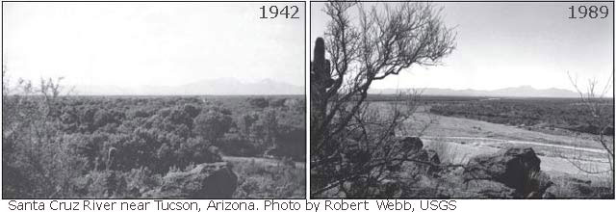
Figure 2. (http://water.usgs.gov/edu/gwdepletion.html)

flow of rivers as you can see in Figure 2. Less annual flows causing vegetation to die off and creates devastating effects to the surrounding ecosystem. To support the growing population, south-central Arizona has lost 300-500 feet of water levels declining in their surrounding area (U.S.G.S., 2016). Nearly all of the southern half of Arizona’s aquifers are facing declines of water levels between 100-200 feet, which can be seen in figure 3. Another impact caused by increase pumping of groundwater is deteriorating water quality. All of the water underground is not fresh water. An estimated 3.1 million cubic miles of saline groundwater exists beneath our feet. The boundary between salt and freshwater is relatively stable until over pumping of freshwater loosens the barrier and contaminates the freshwater. Many farms in south-central Arizona have faced salt-water intrusion in their wells from pumping too much water. Groundwater depletion creates serious risk for the agricultural community, the surrounding ecosystem, and all those in need of fresh water (Burns, 1997). In 1980, Arizona created the Arizona Groundwater Management Act, at the time it was said to be one of the most innovative policies concerning groundwater management at the time.
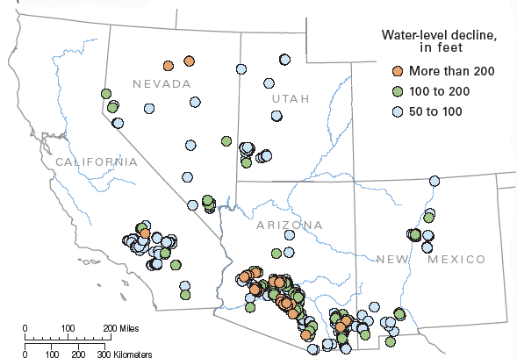

Figure 3. Water levels in South West U.S. (http://pubs.usgs.gov/fs/fs-103-03/)

Concerns of the future of groundwater supplies, the Arizona legislature passed the Arizona Groundwater Management Act in 1980. The goal was to end over-draft of groundwater by 2025 and create a sustainable water supply. This policy has made headway, but inadequately addresses the problem Arizona is facing. Overdraft of groundwater increases water pumping and well drilling costs. The constant usage is eroding the quality of water in aquifers, creating land fissures, and greatly reducing the amount of water in Arizona’s reservoirs. “Two of the biggest reservoir storages of the Colorado River, Lake Powell and Lake Mead are half-full and expert predict the reservoirs will not be full in our lifetime” (Hirt, 2008). Although it may seem like this ‘state of the art’ policy may lead to some improvement, Arizona is still facing critical problems and a more comprehensive solution needs to be created.
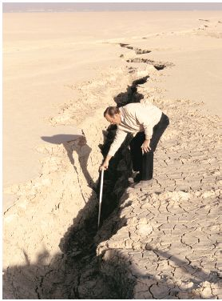
Figure 4. Land fissure on Rogers Lake, California. (http://pubs.usgs.gov/fs/fs-103-03/)
Many solutions can be created to address the problem facing Arizona’s groundwater depletion. Tighter restrictions on the amount of groundwater pumped by private owners of wells needs to be implemented. The Arizona Groundwater Management Act has restrictions in place on private owners, but the constant pumping of water out aquifers will still contaminate and shorten the supply of fresh water. Another solution to reduce the amount of aquifer water is recycling wastewater. This allows for a system to be less dependent on groundwater and focuses on reusing water. Arizona has created a group called the Arizona Drought Monitoring Technical Committee, this committee is designed to monitor all watershed and aquifer levels through out the state and give constant updates on water levels. The committee also creates drought preparedness plans to combat severe droughts coming through out the year and gives estimates as to what water extra water will be needed throughout the state.
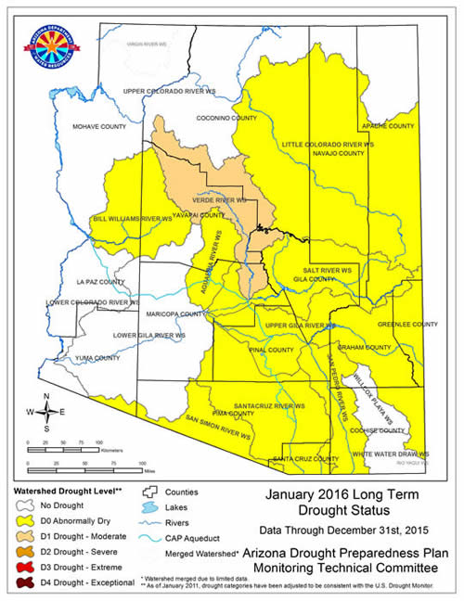

Figure 5. 2016 Long Term Drought Status of Arizona (http://www.azwater.gov/azdwr/StatewidePlanning/Drought/DroughtStatus2.htm).

Sustainability of water will be a constant challenge not only in the Western United States, but is a global risk as well. Aquifers have provided a safety net for those facing hard times with water availability. This safety net is deteriorating and mankind can no longer rely on massive amounts of groundwater to fix the problem. Not only is the supply of freshwater declining, but serious ecological impacts and the integrity of pristine groundwater is eroding to contamination. More policies and a stronger push from the community is needed to restore balance back to the Colorado River Basin and other ecosystems before we eventually deplete these valuable aquifers.

References

Alley, W.M., Reilly, T.E., and Franke, O.L., 1999, Sustainability of ground-water resources: U.S. Geological Survey Circular 1186, 79 p.

Burns, A.W., 1997, Sidebar 2-2—Ground-water resources in the western United States—Sustainability and trends, in Western Water Policy Review Council, Water for the West—The challenge for the next century, Public Review Draft, October 1997, p. 2.10-2.16

“Drought Program.” Arizona Department of Water Sources. Azwater.gov. Last Modified April 1, 2016, http://www.azwater.gov/azdwr/StatewidePlanning/Drought/DroughtStatus2.htm

Hirt, Paul, Annie Gustafson, and Kelli L. Larson. 2008. “The Mirage in the Valley of the Sun”. Environmental History 13 (3). [Forest History Society, Forest History Society and The American Society for Environmental History, American Society for Environmental History, Oxford University Press]: 482–514. http://www.jstor.org/stable/25473264.

Taylor, C.J., and Alley, W.M., 2001, Ground-waterlevel monitoring and the importance of long-term water-level data: U.S. Geological Survey Circular 1217, 68 p

