Everyone has heard about the California water crisis and knows that due to a lack of early water standards, how the population is spread throughout the state, location of annual precipitation and various other reasons, that the topic of water is a very controversial subject, especially within the state between Northern and Southern California. From the beginning of the state of California water has always been a resource that has needed to be transported because of the terrain of the state. Due to this the State completed a very intense survey that would go over current water resources, water utilization and a plan to develop, control and utilize water resources while taking into account flood control, power, underground reservoirs and preservation of fish, wildlife and recreation.

Picture #1 below shows that most of the precipitation that falls in the state is in Northern California but most of the need for water is in Southern California. You can also gain an idea of how much annual precipitation California receives and the amount that evaporates vs. the amount that is available for use, then it breaks down the categories of use.

Picture #1

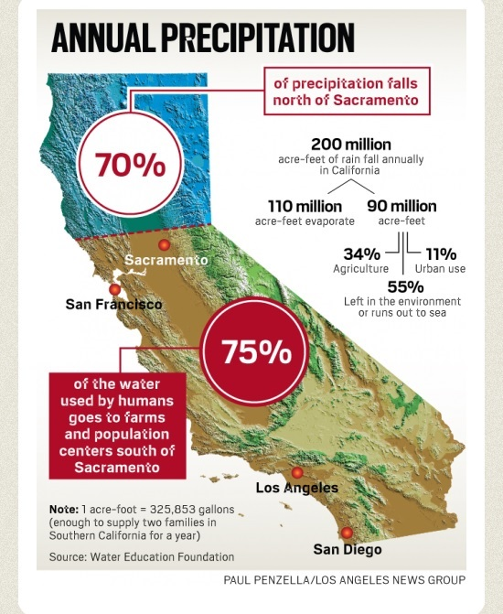

Within the last 50 plus years California’s government has been putting water policy and planning on the front lines of almost every topic as this is a natural resource that has an impact on almost every aspect of life and state. Even before this time water was always a topic for discussion but it wasn’t as centralized, and it included the Federal government trying to take over for a while. The State is always trying to find ways to sustain its growing population and the extremely diverse environment that is the State of California. California has long been known as being environmentally conscientious and having innovative thinkers. This can be seen in the way in which they put in the needed time, effort and funds necessary to build and maintain a long lasting and environmentally friendly water system.

The California State Water Project (SWP) is a water storage and delivery system of reservoirs, aqueducts, power plants and pumping plants. It extends for more than 600 miles, two-thirds the length of California. It is one of the largest state built, multi-purpose water projects in the United States and supplies more than 25 million Californians in Northern California, the Bay Area, San Joaquin Valley, Central Coast and Southern California. The project was initially started in 1947 when an updated study was approved by the Legislature. The main goals of the study were/are to complete and initial inventory of the water resources the state had up to that point, current water utilization which allowed them to estimate future water needs, and to plan for full practicable development, control and utilization of water resources. The plan involves being able to bring water to every irrigable and habitable acre, flood control- to reduce water waste, hydroelectric power, salinity control, replenishment of underground reservoirs and the preservation of fish, wildlife and recreation. Picture #2 shows a detailed map of the water storage and delivery system that was approved.

Picture #2

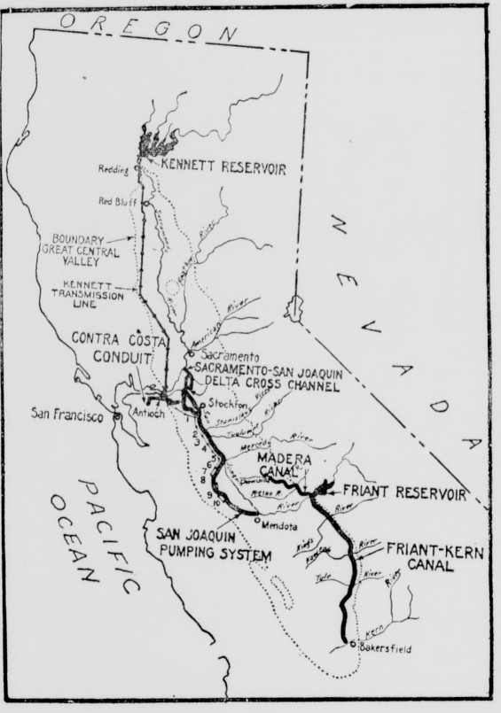

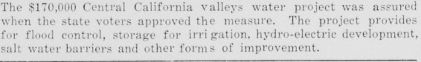

Once the project was approved the state took a lot of time to compile studies and make sure they were planning for the future and getting feedback from all interested parties. It took six years before construction began on the first facilities. During the planning, design and construction process of the major SWP facilities features were incorporated that would aid in mitigating impacts to and provide enhancement for fish and wildlife. Some of the forward thinking features, such as the multiple-level outlet structure at Oroville Dam, that help control water temperature for fish, demonstrate the SWP’s commitment to the environment from its earliest days. Other features include, Picture #3, the Oroville spillway that is used to aid with flood control that saves lives, property and water. In picture #4 we get a nice depiction on how the Oroville Dam is structured. After the main facilities were set work began on the aqueducts in 1963 it took a couple of years before they were able to deliver water.

Picture #3

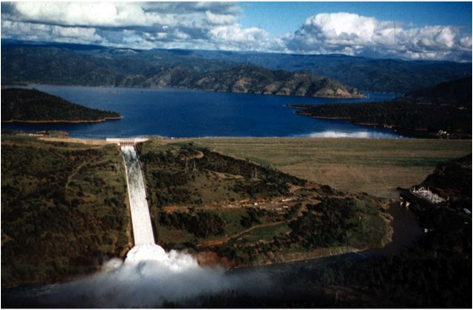

Picture #4

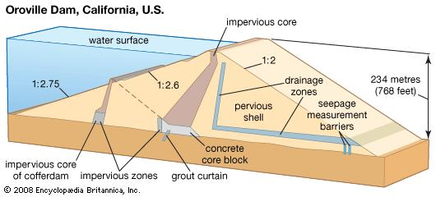

The job of balancing environmental concerns and moving water has become an ever-increasing challenge. New and even stricter regulations have made compliance more complex for the operations of the SWP. We can see a water resource timeline in picture #5 that shows how water resource, policy and regulations have evolved since the 1860’s. Initially the state formed local levee and reclamation districts knowing that each community would have differing needs. Most of the policies and initiatives in the 1900’s focused on reasonable and beneficial use, state or federal control and how to provide the needed resources to all viable parties while thinking of the environment and the future.

As we can see California has a very sensitive subject that is always at the height of conversation with everyone having a different idea or opinion on the best way to solve the problem. When it comes down to Northern vs. Southern California and how the resources should be distributed the solution is always a moving target. We can see that progress is continually made especially when we look at how California implemented the State Water Project. This plan took a lot of time, effort and money for the planning stage which looked into current inventory, determining water utilization both past, present and future and a plan for development, control and utilization of water resources for the entire state. With projects such as SWP we can see that California really does take the time, put in the effort and is able to provide the funds needed to build and maintain a long lasting, ever evolving and environmentally friendly water system.

Picture #5

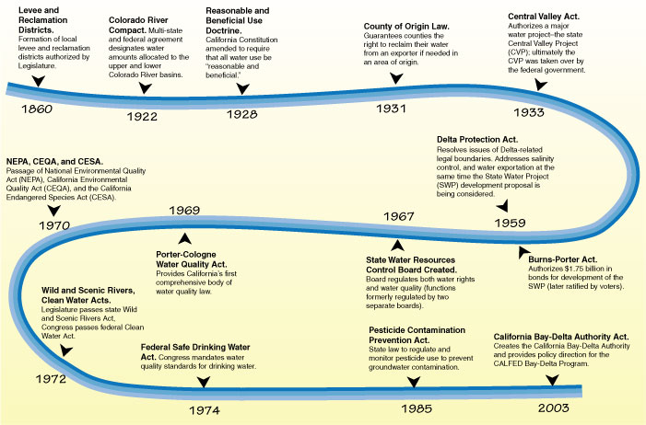

**Bibliography**

**Primary Sources:**

(1) Shelton, Mercel J.. 1959. “Progress of the California Water Plan”. *Journal (american Water Works Association)* 51 (11). American Water Works Association: 1349–56. <http://www.jstor.org/stable/41255940>.

(2) Griffith, C. A.. 1955. “Development of the California Water Plan”. *Journal (american Water Works Association)* 47 (4). American Water Works Association: 367–73. <http://www.jstor.org/stable/41253980>.

(3) Berry, William L.. 1950. “The California Water Plan”. *Journal (american Water Works Association)* 42 (4). American Water Works Association: 381–85. <http://www.jstor.org/stable/41235456>.

**Secondary Sources:**

(1) “State Water Project” last modified 10/23/2012 <http://www.water.ca.gov/state_water_project_home.cfm>

(2) “California state water project overview” last modified 8/11/2010 <http://www.water.ca.gov/swp/>

(3) “California Water Blog“ last modified 9/13/2011 <https://californiawaterblog.com/2011/09/13/water-storage-in-california-2/>

(4) “Californias Water: an LAO Primer” last modified 10/22/2008, <http://www.lao.ca.gov/2008/rsrc/water_primer/water_primer_102208.aspx>

**Pictures:**

(1) “Hydrowonk blog” last modified 4/16/2014 <http://hydrowonk.com/blog/2014/04/16/a-tale-of-two-california-water-supplies-the-state-water-project-vs-the-colorado-river/>

## (2) Vast Water Project is Approved, Healdsburg Tribune, Number 42, 21 December 1933, <http://cdnc.ucr.edu/cgi-bin/cdnc?a=d&d=HT19331221.2.15&srpos=1&e=-------en--20--1--txt-txIN-California+State+Water+Project-------1>

(3) Lake Oroville spillway, 1997 (Rand Schaal), <https://californiawaterblog.com/2011/09/13/water-storage-in-california-2/>

## (4) Dam, <http://www.britannica.com/technology/dam-engineering>

## (5) Selected Events in State Water Policy History—A Timeline, <http://www.lao.ca.gov/2008/rsrc/water_primer/water_primer_102208.aspx>.