Steven Huber

History 100

Pictorial Essay

**The Threat to Aquifers in the American West**

Freshwater is crucial to earth’s hydrologic cycle and the survival of the human race. It comes in a variety of forms, including; precipitation, ice caps, glaciers, rivers, and lakes. One of the most important sources of freshwater, however, cannot be seen by the naked eye, but is rather hidden beneath our feet. Groundwater can be found in underground layers of permeable rock, referred to as aquifers. According to the National Oceanic and Atmospheric Administration (NOAA), 30 percent of our liquid freshwater is groundwater – making it an essential source for both drinking water and for irrigational use. Aquifers function by being brought to the surface through natural springs or by pumping, and are then recharged by surface water flowing into them, often near mountains due to the steep slopes. The problem facing the American West today is that aquifers are currently being exhausted at rates faster than they can be recharged. Studies show that groundwater in the Colorado River Basin, which can take thousands of years to recharge naturally, is being depleted 6 times faster than surface water. Human’s use of aquifers has become unsustainable and will have devastating consequences unless policies and mindsets are changed as soon as possible.

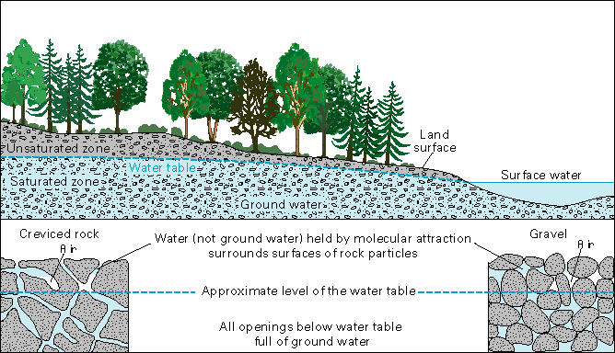

Figure 1: The diagram above shows the different levels and components of a groundwater system

When aquifers are depleted faster than they can be recharged, the surrounding water table is also affected. The water table is the level at which the subsurface materials below are saturated with water. While the level of a water table may temporarily fluctuate based on the season or amount of precipitation in a given area, water tables in the American West have been seeing more long-term effects caused by the removal of fossil water. Fossil water is groundwater that has remained in an aquifer for several millennia and is considered non-renewable due to its depth below the surface. Fossil water is primarily extracted for agricultural uses and its extraction has permanent effects on the water table located above. When water tables drop low enough that their level falls below the depth of a well, the well will essentially run dry until the groundwater is recharged, a process that can take hundreds or thousands of years. Another problem caused by the lowering of a water table is subsidence. Subsidence is the process of the ground sinking due to groundwater pumping. In California’s southern San Joaquin Valley, an area used heavily for farming, the land surface settled 28 feet between the 1920s and 1970s. Subsidence is not only a threat to aquifers below, but also to infrastructure on the surface. Other harmful effects of lowered water tables include reduced surface water in lakes and streams, increased costs for pumping (since the water becomes located deeper and deeper), and water contamination – especially in coastal areas where excessive pumping causes saltwater to move inland and contaminate the water supply.

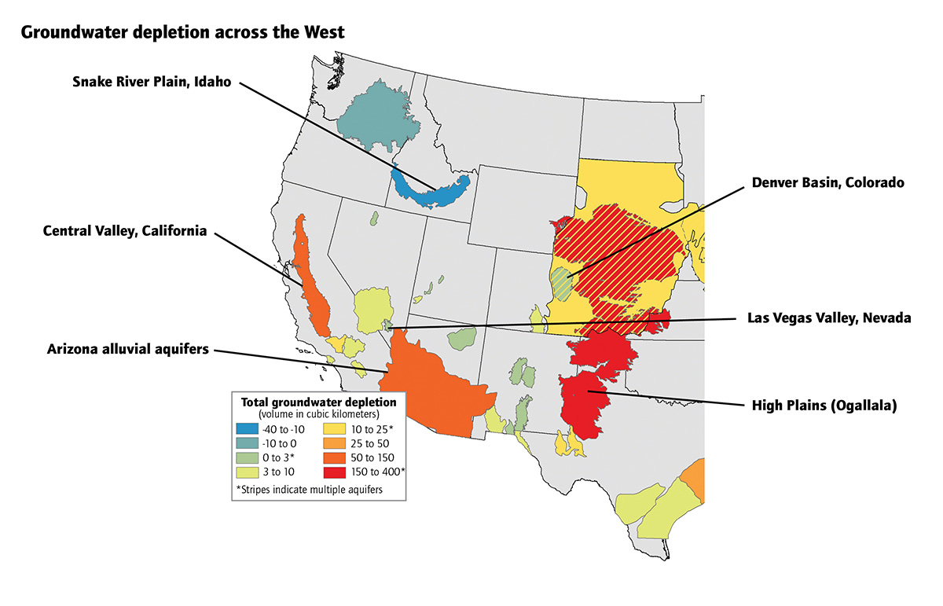

Figure 2: Depletion of aquifers in the western United States

Another effect of human activity on aquifers is groundwater pollution. This contamination occurs when man-made products such as gasoline, oil, road salts, and chemicals leach through soil and enter aquifers. A large source of groundwater contamination is the pesticides and fertilizers used in irrigation. Other sources include faulty septic systems and landfills. Drinking water that has been contaminated with toxins can cause diseases such as hepatitis, dysentery, and even cancer if there is an extended exposure to polluted water. Contaminated groundwater can also harm wildlife. Besides man-made sources, contamination can occur naturally from mineral and metallic deposits in rock and soil. Once contaminants reach groundwater, they tend to form a concentrated plume that flows along with the water since groundwater tends to mover very slowly and with little turbulence. These contaminated plumes often go undetected for years and can spread over large areas. Cleanup can be a lengthy and expensive process. The methods of cleanup include containing the contaminants to prevent them from migrating from their source, removing the contaminants from the aquifer, remediating the aquifer by either immobilizing or detoxifying the contaminants while they are still in the aquifer, treating the groundwater at its point of use, and abandoning the use of the aquifer and finding an alternative source of water. There have been several federal laws directed at either preventing or remediating groundwater contamination. The two major laws include the Resource Conservation and Recovery Act (RCRA) and the Comprehensive Environmental Response, Compensation, and Liability Act (CERCLA). RCRA regulates the storage, transportation, treatment, and disposal of solid and hazardous wastes, and emphasizes prevention of releases through management standards. CERCLA regulates the cleanup of abandoned waste sites or operating facilities that have contaminated soil or groundwater.

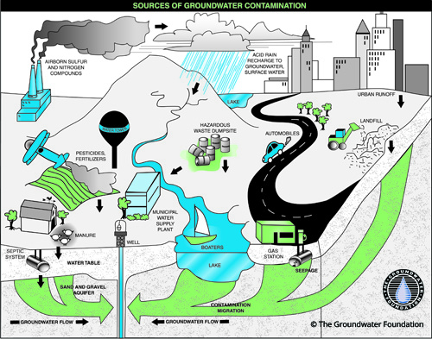

Figure 3: Sources of human-caused groundwater contamination

So what can be done to protect our nation’s aquifers and ensure that they remain clean and bountiful for future generations? The biggest thing we can do is manage our water usage and the pumping of water from aquifers. Regulation and monitoring of groundwater extraction have historically been very rare. While the surface water of the Colorado River Basin has been apportioned according to the Colorado River Compact since 1922, the extraction of groundwater has largely been the local right of the landowner – meaning that if you own the property, you can drill a well and pump as much water as you want. However, in recent years this has changed in a few states. Arizona passed the Groundwater Management Act in 1980, which created five tightly sealed basins and limits groundwater pumping. Likewise, the governor of California, Jerry Brown, has called for a crackdown on excessive withdrawals and proposed bills that would give the state more authority to monitor and regulate groundwater withdrawal. It is clear that more policies must be put in place to regulate and protect our nation’s valuable aquifers before they become over-exhausted and the problem of fresh water availability is further exacerbated.

**Bibliography**

Hand, Eric. "Western U.S. States Using up Ground Water at an Alarming Rate." Western U.S. States Using up Ground Water at an Alarming Rate. July 24, 2014. Accessed April 02, 2016. http://www.sciencemag.org/news/2014/07/western-us-states-using-ground-water-alarming-rate.

Handwerk, Brian. "Underground "Fossil Water" Running Out." National Geographic. May 8, 2010. Accessed April 02, 2016. http://news.nationalgeographic.com/news/2010/05/100505-fossil-water-radioactive-science-environment/.

Oskin, Becky. "Aquifers: Underground Stores of Freshwater." LiveScience. January 14, 2015. Accessed April 02, 2016. http://www.livescience.com/39625-aquifers.html.

Owen, David. "The Disappearing Colorado River." The New Yorker. May 25, 2015. Accessed April 02, 2016. http://www.newyorker.com/magazine/2015/05/25/the-disappearing-river.

"Water Encyclopedia." Pollution of Groundwater. Accessed April 02, 2016. http://www.waterencyclopedia.com/Oc-Po/Pollution-of-Groundwater.html.

"The Drying of the West." The Economist. February 22, 2014. Accessed April 02, 2016. http://www.economist.com/news/united-states/21596955-drought-forcing-westerners-consider-wasting-less-water-drying-west.

"Potential Threats to Our Groundwater." The Groundwater Foundation. Accessed April 02, 2016. http://www.groundwater.org/get-informed/groundwater/overuse.html.

"Aquifers and Groundwater." The USGS Water-Science School. Accessed April 02, 2016. http://water.usgs.gov/edu/earthgwaquifer.html.