Jessica Fontenot
Boise State University- History 100
Pictorial Essay
Historical Engineering of Ground Water in Snake River Valley
Idaho is known for its beautiful landscapes, outdoor activities, and agriculture. But Idaho has not always been known for having such a dominant agricultural background. In the early 1800’s farmers were only able to pull surface water near the Snake River to irrigate their farms. This meant that only a small portion of Idaho at that time was being used to cultivate crops. That is until an underground aquifer was found by drilling wells in the early 1950’s. Drawing water from the aquifer expands agricultural opportunities in Idaho and benefits the state economy. This investment of resources in irrigation reveals a desire for Idaho to create and sustain a rural culture and remain independent from other states.
Early farming in Idaho proved to be a difficult challenge. The earliest Homestead Act (1862) settlements in southern Idaho were quickly abandoned, as individual farms, absent irrigation structures and modern pumping, were no match for a dry climate (1). Much of the land was used as range, not as cropland (2). The need for advancement in water irrigation came in the form of the Reclamation Act of 1902. This act allowed the U.S. Reclamation Service to build dams and canals to supply water to settlers (3). The purpose of this project was to serve as many farmers as possible, so bureaucrats and engineers designed canal systems and storage structures of massive, breathtaking size (4). Building dams diverted water into canal systems and then into conduits to irrigate the farmland. Farmers labored by digging their own ditches to pull water from the delivery systems to irrigate their crops. Although the dams and canals made it possible for more land to be cultivated and irrigated properly, this was still a labor-intensive process.

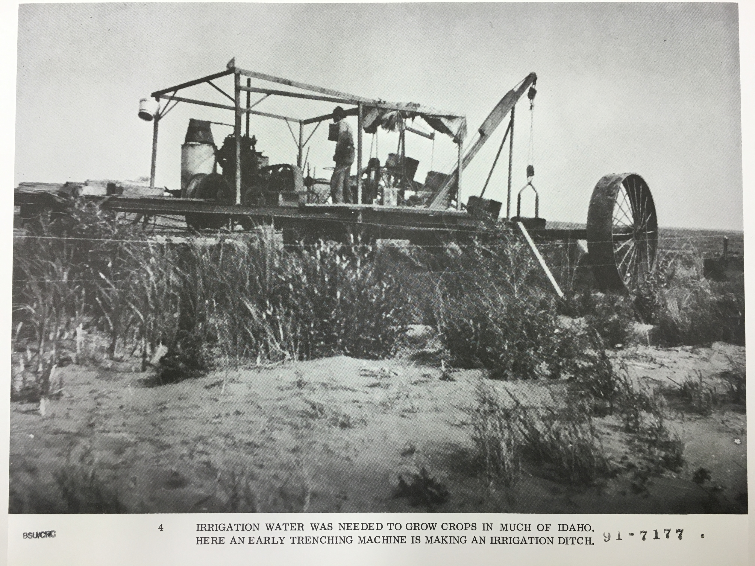
1. This picture illustrates early machinery used to dig ditches. Not only did engineers have to construct plans for irrigation, but also for the machines and tools to do the work.
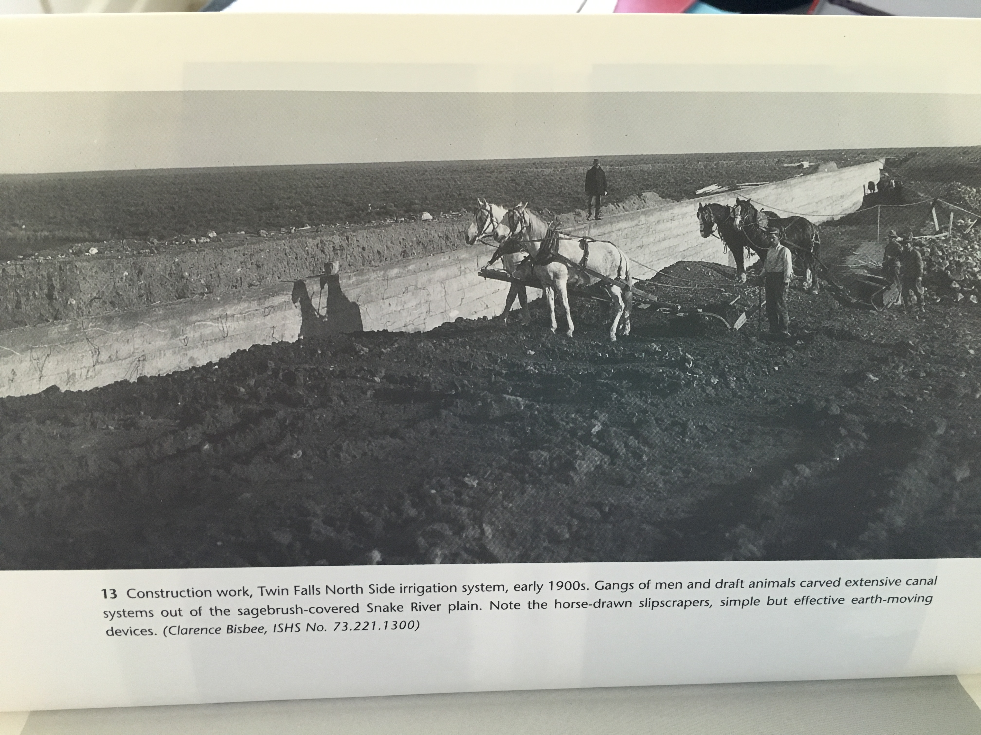
2. This picture shows how workers utilized the strength of draft animals to work on projects that required heavy lifting and pulling. This illustrates the ingenuity of early workers and it shows how easy it is to take current methods (tractors, forklifts) for granted.

About 1950 pumping technology reached a point that it became economic to draw groundwater for irrigation above the aquifer (5). An aquifer is a natural underground area where large quantities of ground water fill the spaces between rocks and sediment. According to Idaho's "Ground Water Quality Rule" (IDAPA 58.01.11.007.02), to be considered an aquifer in Idaho, the area must produce "economically significant quantities of water to wells and springs” (6). Advancement in this pumping technology, drilling wells and pumping groundwater from the aquifer, made it possible for a family of four to claim a full section of desert, providing water by means of a high-lift pump, no canal, dam or diversion required (7). More applications (for land) were filed between 1950 and 1956 than in the previous 30 years combined (8). Groundwater irrigation rose from 100,000 acres in 1950 to 700,000 acres in 1965 and 1.1 million acres by 1980 (9).

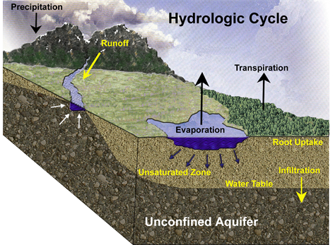
3. This is an example of an aquifer and how it flows.

With this new development of technology, lands that were unable to be irrigated because they lay above the river were now available. As seen in the statistics above, the amount of acres that could be irrigated and cultivated grew immensely. Thus giving Idaho its strong agricultural roots. Products such a potatoes, alfalfa (hay), sugar beets, and wheat to name a few are produced in Idaho.

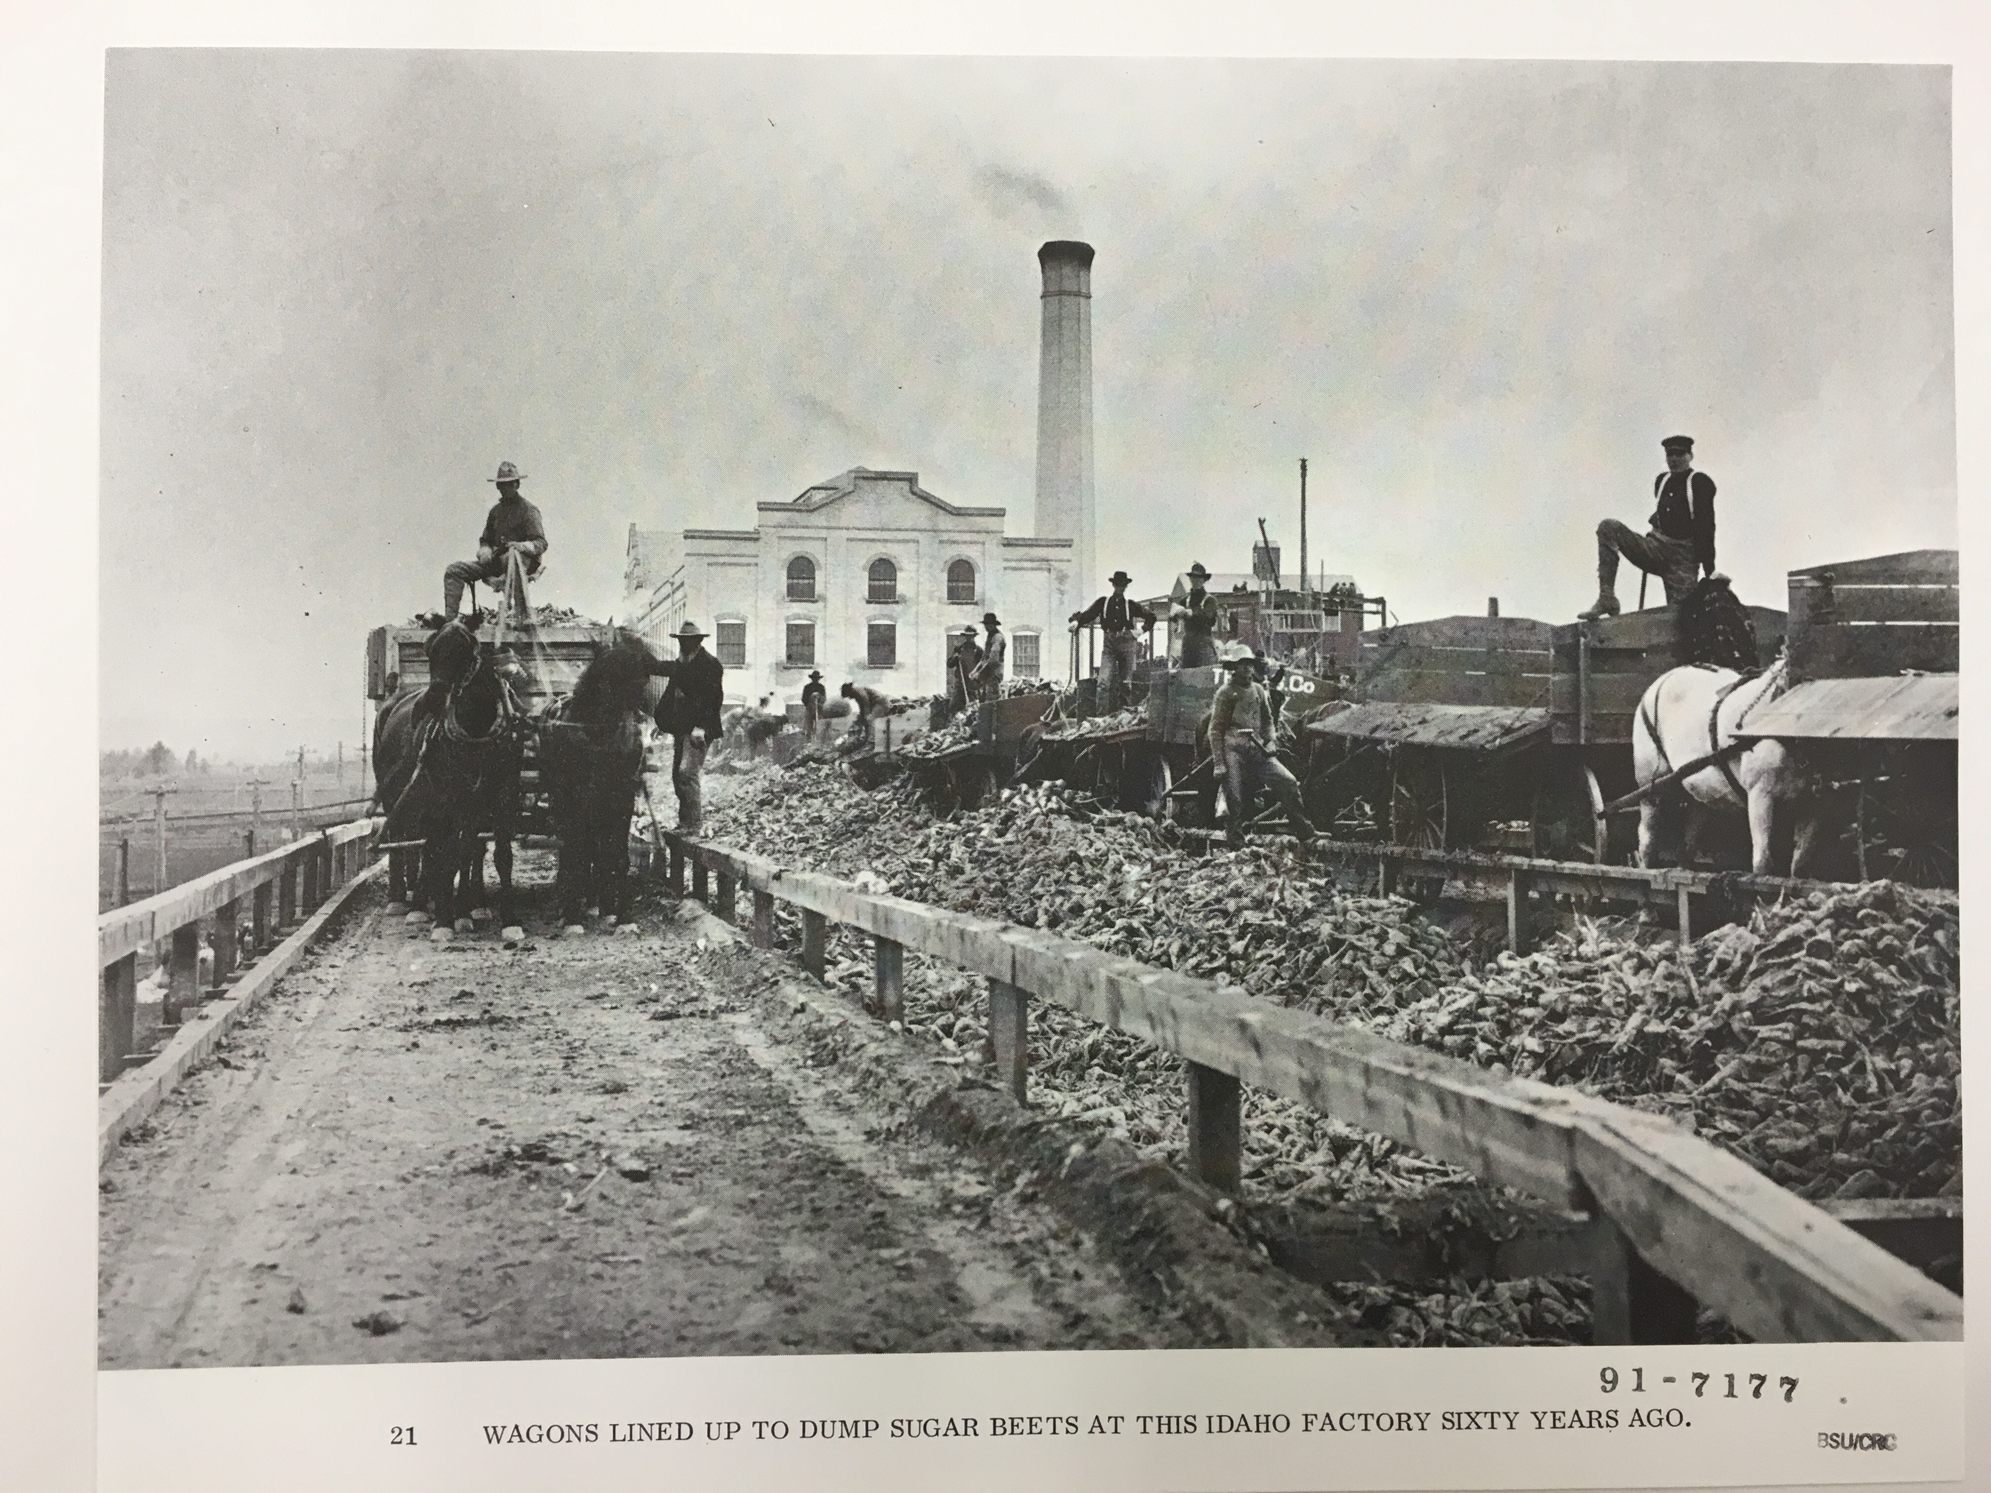
4. This picture illustrates sugar beets being processed and brought in from the farm. Most people think of potatoes as Idaho’s crown jewel, but many other important crops are grown in Idaho.

Being able to utilize and manage a natural resource comes with great responsibility. Per state jurisdiction, a landowner must apply for and possess a permit to use groundwater (10). This same jurisdiction requires that all groundwater users install meters to measure withdrawals from the aquifer (11). This allows the state to appropriately allocate water, save resources where possible and recharge the aquifer to ensure an economically safe Idaho.
Along with groundwater being an important component to shaping the history and current economy of Idaho, Idahoan settler’s strong beliefs and values shaped its culture. Migrating to the west and attempting to settle in Idaho took a lot of guts and vision. As mentioned earlier, southern Idaho is mostly desert landscape, which made it difficult to plant crops and make a living. “The irrigated landscape was not a place in which humans mastered nature. Rather, it was the site of ongoing interaction between people and the land, a reciprocal interplay in which irrigators seldom if ever achieved the control they desired” (12). But by working with nature and continuing to perfect the engineering of water systems, Idaho was able to eventually flourish.
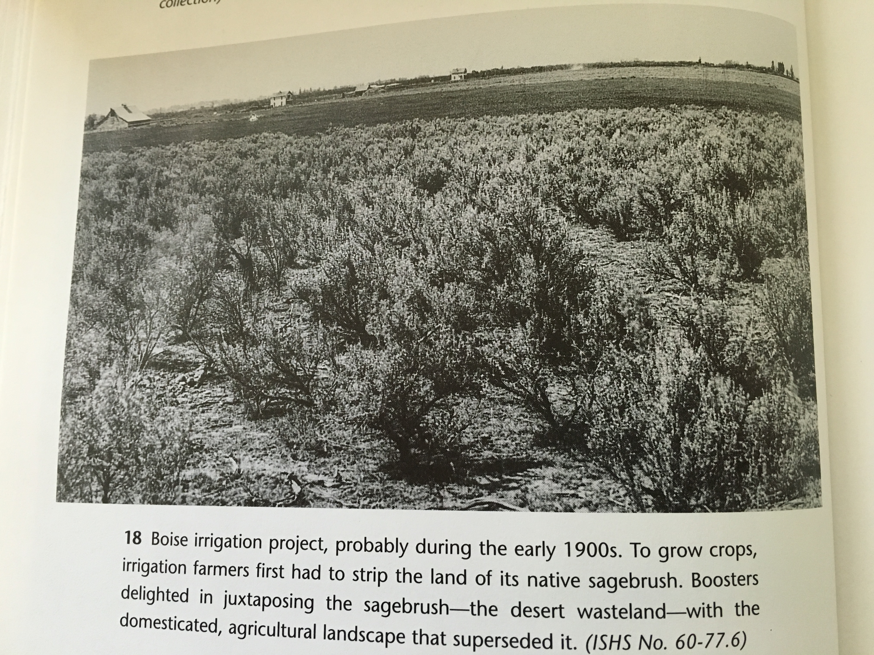
5. This is a great photo because it shows the desert landscape, sagebrush, and a farm in the background. It’s really the epitome of Idaho. Harsh terrain turned into workable farmland by the engineering of groundwater.

Those who migrated west to Idaho wanted more for themselves and their families. Land to own, work from, and supply financial stability. Families worked hard together to get their farms up and running. “Irrigated agriculture, as many of its proponents envisioned it, would provide Americans an escape from the worst effects of industrialization and the urbanization that accompanied it. But ironically, in Idaho’s Snake River valley, labor linked America’s agrarian past and its onrushing industrial future” (13).
Some may envision that Idaho has always had farmland and it has been around for generations. Irrigation and agriculture in Idaho is actually newer than most would expect. As discussed earlier, the immense growth in agriculture because of new pumping technology did not happen until the early 1950’s. This, however, does not discredit the hard work and creativity that came with early settlers. To these people, the irrigated landscape frequently, although not always, objectified a deeply compelling story-the garden myth (14). This myth encompasses westward-moving pioneers that conquered the howling wilderness and transformed it into beautiful, productive fields and farms (15).
Today many Idahoans, especially those who come from an agricultural background, are very proud of the beliefs and values that this state was founded on. Without the engineering of new water technology, Idaho may not have thrived agriculturally and it may not have been a staple of our economy. Investing in this resource and continually finding ways to balance the use of natural resources benefits Idaho and maintains independence from other state resources.

BIBLIOGRAPHY
- Slaughter A., Richard, Ph.D., “Institutional History of the Snake River 1850-2004” Environmental History (2004): Page 4.
- Kimball, N.D. “Irrigation Development in Idaho: Under the Desert Land Act”, University of Idaho College of Agriculture, no 292 (1958). Page 6.
- Fiege, Mark, Irrigated Eden; The Making of an Agricultural Landscape in the American West (Seattle: University of Washington Press, 1999). Page 124.
- Fiege, Page 124.
- Slaughter, Page 10.
- Idaho Department of Environmental Quality. Ground Water in Idaho (2016). Ed Hagan- Ground Water Program Manager. https://www.deq.idaho.gov/water-quality/ground-water/aquifers/
- Slaughter, Page 4.
- Kimball, Page 3.
- Slaughter, Page 4.
- Slaughter, Page 10.
- Slaughter, Page 10.
- Fiege, Page 12.
- Fiege, Page 140.
- Fiege, Page 171.
- Fiege, Page 171.

PHOTOS
- Idaho Historical Society picture series #2. “Farming in Idaho”. Boise State University.
- Fiege, Mark, Irrigated Eden; The Making of an Agricultural Landscape in the American West (Seattle: University of Washington Press, 1999).
- Idaho Department of Environmental Quality. Ground Water in Idaho (2016). Ed Hagan- Ground Water Program Manager. https://www.deq.idaho.gov/water-quality/ground-water/aquifers/
- Idaho Historical Society picture series #2. “Farming in Idaho”. Boise State University.
- Fiege, Mark, Irrigated Eden; The Making of an Agricultural Landscape in the American West (Seattle: University of Washington Press, 1999).

