Caitlyn Moyle
Professor Leslie Madsen-Brooks
History 100
Pictorial Essay Redo
Continued and Increased Use of Dams & Reservoirs is Harmful
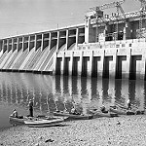
In simple terms, a dam is “Any barrier that holds back water” (1). A reservoir is “an artificial lake where water is stored” (2). Dams and reservoirs are man-made engineered structures that have been used to store water for agricultural, industrial and household uses for thousands of years (3). The oldest known dam in the world is the Jawa Dam in Jordan, built around 3000 BCE (4). Some specific functions that dams and reservoirs provide for society are to maintain an area’s water supply, generate hydroelectric power, stabilize water flow and irrigation, prevent floods, and even recreation like boating (5). While all of these functions certainly make human life easier and water more available to some people, there is heavy amounts of controversy surrounding the continued construction of dams for both environmental and social reasons. The fact that there are over 48,000 dams in operation around the world with many more being built or planned (6), despite much consequence to nature and people alike, reflects that society as a whole values functionality and control over resources and tends not to care about consequences until they must be directly dealt with. The photograph from the Missouri State Archives above is of the Bagnell Dam in Missouri. This is an example of a large dam.
Photo Source: (https://www.flickr.com/photos/missouristatearchives/11653596505/in/photolist-iKMJeF-iKREwU-iKRDPb-iKP3Mi-DeURiH-bU3Qaa-9KdTMZ-hgzrPN-bF9xnJ-6nBFQn-7VF19u-4jCibf-5EWcp1-6BqQVv-bDHVCd-obTZnf-iaynwE-hnJUN1-khM2dY-khJAnk-pEvQn6-hgB9fK-8Hf98Q-8LVSLx-iKRDTE-9qQ2Ve-iKMHwZ-dmY8Gu-q1zJoq-4juPwH-bSC1wV-5wkjXh-hgtc1Q-ocUqKK-nKhRUM-hENjhP-n19M3r-octQ48-q3F9ir-hgsjzu-bDHdts-82GpF5-wP52QT-bF991s-hgsXHC-cXVpzC-4jCinb-x4sz5q-4jyfDP-fEP42D)
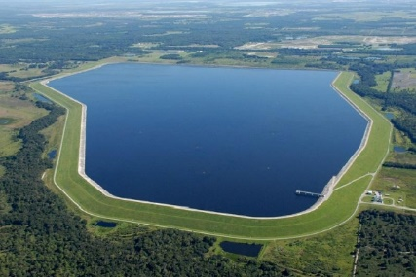
This photograph is of the C.W. Bill Young Regional Reservoir in Hillsborough County, Florida. This seems like a large reservoir, but there are many that are even larger. The reservoir provides water access for the surrounding counties. The reservoir has faced issues with cracking in the soil-cement erosion-control layer, but have undergone renovations to ensure its continued use (7).
Photo Source: http://www.water-technology.net/projects/cw-bill-young-regional-reservoir-renovation-project-florida/
- "Overview of Dams and Reservoirs." About.com Education. Accessed April 25, 2016. http://geography.about.com/od/waterandice/a/damsreservoirs.htm.
- "Reservoir." National Geographic Education. 2011. Accessed April 25, 2016. http://education.nationalgeographic.org/encyclopedia/reservoir/.
- Dams and Reservoirs." Terrascope Websites. Accessed April 25, 2016. http://12.000.scripts.mit.edu/mission2017/dams-and-reservoirs/.
- "Reservoir." National Geographic Education. 2011. Accessed April 25, 2016. http://education.nationalgeographic.org/encyclopedia/reservoir/.
- "Overview of Dams and Reservoirs." About.com Education. Accessed April 25, 2016. http://geography.about.com/od/waterandice/a/damsreservoirs.htm.
- "Dams Initiative." Dams. Accessed April 25, 2016. http://wwf.panda.org/what_we_do/footprint/water/dams_initiative/.
- "C.W. Bill Young Regional Reservoir Renovation Project, Florida." Water Technology. Accessed April 25, 2016. http://www.water-technology.net/projects/cw-bill-young-regional-reservoir-renovation-project-florida/.
Many of the detrimental impacts of man-made dams are ecological. Some of those impacts in highest controversy include changes in fish migration, erosion, changes in water temperature and oxygen levels which creates environments for many species that are not hospitable, and river fragmentation (8).
- "Reservoir." National Geographic Education. 2011. Accessed April 25, 2016. http://education.nationalgeographic.org/encyclopedia/reservoir/.

River fragmentation occurs through “the interruption of a river’s natural flow by dams,” (9) and is harmful to animals and people alike. The natural flow and connectivity of rivers are necessary to sustain the biophysical and ecological processes necessary for life in freshwaters. These characteristics are disrupted when rivers are fragmented by dams and their reservoirs. Fragmentation causes a loss of ecosystem processes that negatively affects all who rely on it. A fragmentation analysis of 227 rivers done by the University of Umea and the World Resources Institute showed some alarming data concerning the world’s rivers and their current fragmentation status. The analysis showed that
- “Strongly or moderately fragmented systems accounted for nearly 90% of the total water volume flowing through the rivers analyzed.” A strongly fragmented river system is a river “with less than a quarter of their main channel remaining without dams, where the largest tributary has at least one dam, as well as rivers where the annual flow pattern has changed substantially."
- The only large free-flowing rivers left on Earth are in the tundra regions of North America and Russia, and in smaller coastal basins in Africa and Latin America.
- “The last three decades several inland ecosystems, like the Aral Sea, Lake Chad, and the Mesopotamian Marshlands, have declined in size and function.” (10)
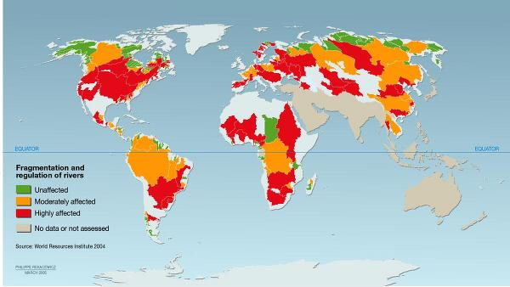
This colored map of the world below shows unaffected rivers in green, moderately fragmented rivers in yellow, and heavily fragmented rivers in red. This map is from the same source as the data of the river fragmentation analysis. As it becomes clear, nearly all of the United States and large sections of other parts of the world have strongly fragmented rivers and freshwater systems. This kind of disregard for the facts that I have so easily found demonstrates the value that people place on function and control, with lack of care for consequences.
Photo Source: http://www.unep.org/dewa/vitalwater/article95.html

- "Vital Water Graphics." Level of River Fragmentation and Flow Regulation -. Accessed April 25, 2016. http://www.unep.org/dewa/vitalwater/article95.html.
10. "Vital Water Graphics." Level of River Fragmentation and Flow Regulation -. Accessed April 25, 2016. http://www.unep.org/dewa/vitalwater/article95.html.

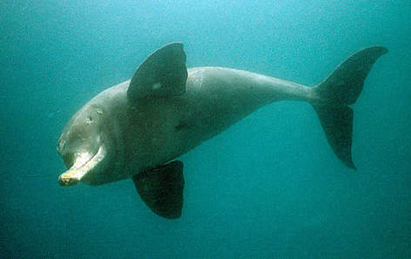
A WWF report, “Rivers at Risk” found that over 60% of the world’s largest rivers are fragmented. The most at-risk is the Yangtze River with 46 dams either in construction or planned. Other rivers at risk include the Danube and the Amazon. Additionally, they reported that dams have destroyed wetlands and caused a decline in freshwater species (11). One freshwater species that is in decline that the WWF touches on is the river dolphin, pictured below. This species is critically endangered, with one direct cause being dam-building in some of the world’s strongest rivers, including the Yangtze (12).

Photo Source: http://wwf.panda.org/what_we_do/endangered_species/cetaceans/about/river_dolphins/
Dams also have negative effects on people and society. One of which is forced evacuation. Construction of the Three Gorges Dam in China required an evacuation of over one million people, all of them losing their homes, to make room for the reservoir that would hold the water behind the 2,309-meter-long dam. The dam was constructed on the Yangtze River to provide inexpensive energy for rapidly growing China (13).
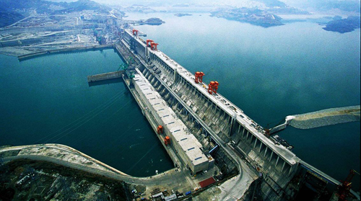
To the left is an amazing view of the massive Three Gorges Dam as it stands today. This picture gives a feel for how large the reservoir must be to accompany this dam. While the dam is a spectacular feat and provides clean power, the desire to be in control over our resources surpassed the importance of the homes and livelihoods of those many people who had to leave.
Photo Source: http://newamericamedia.org/2011/05/lives-interrupted---china-and-the-three-gorges-dam.php
In conclusion, after sifting through data and images of the various different impacts that dams and reservoirs have on people and nature, it becomes clear that my thesis is supported: The fact that there are dams and reservoirs in operation around the world with many more being built or planned, despite much consequence to nature and people alike, reflects that society as a whole values functionality and control over resources and tends not to care about consequences until they must be directly dealt with. We see this ring true with the continued construction of dams despite data about river fragmentation. We saw from the colored map of the world that nearly all the analyzed rivers in the United States are heavily fragmented. We saw it with the river dolphins disappearing, and with the evacuation of over a million people from the location of the Three Gorges Reservoir. While dams and reservoirs can be extremely useful for society, we need to take a look at what is more important, and balance accordingly.
- "Dams Initiative." Dams. Accessed April 25, 2016. http://wwf.panda.org/what_we_do/footprint/water/dams_initiative/.
- "River Dolphins." WWF Conserves Our Planet, Habitats, & Species like the Panda & Tiger. Accessed April 25, 2016. http://wwf.panda.org/what_we_do/endangered_species/cetaceans/about/river_dolphins/.
- "Last Three Gorges Dam Migrants Evacuate as Water Rises." Reuters. 2008. Accessed April 25, 2016. http://www.reuters.com/article/us-china-dam-idUSPEK33854920080723.

Sources

(1,5.) "Overview of Dams and Reservoirs." About.com Education. Accessed April 25, 2016. http://geography.about.com/od/waterandice/a/damsreservoirs.htm.

(2,4,8.) "Reservoir." National Geographic Education. 2011. Accessed April 25, 2016. http://education.nationalgeographic.org/encyclopedia/reservoir/.

(3.)"Dams and Reservoirs." Terrascope Websites. Accessed April 25, 2016. http://12.000.scripts.mit.edu/mission2017/dams-and-reservoirs/.

(6,11.) "Dams Initiative." Dams. Accessed April 25, 2016. http://wwf.panda.org/what_we_do/footprint/water/dams_initiative/.

(7.)"C.W. Bill Young Regional Reservoir Renovation Project, Florida." Water Technology. Accessed April 25, 2016. http://www.water-technology.net/projects/cw-bill-young-regional-reservoir-renovation-project-florida/.

(9,10.)"Vital Water Graphics." Level of River Fragmentation and Flow Regulation -. Accessed April 25, 2016. http://www.unep.org/dewa/vitalwater/article95.html.

(12.)"River Dolphins." WWF Conserves Our Planet, Habitats, & Species like the Panda & Tiger. Accessed April 25, 2016. http://wwf.panda.org/what_we_do/endangered_species/cetaceans/about/river_dolphins/.

(13.)"Last Three Gorges Dam Migrants Evacuate as Water Rises." Reuters. 2008. Accessed April 25, 2016. http://www.reuters.com/article/us-china-dam-idUSPEK33854920080723.

