Water Usage in the American West

Farming was how settlers lived and got by everyday. Irrigation is a key ingredient for a successful harvesting field because that is how water got to the crops. There would be dams built in order for streams or rivers to flow into them and eventually lead into the owner’s fields for harvesting such things like potatoes or crops. In the picture below you will see the walls made of rock in order to trap the waters in the hole. Irrigation was the most important and crucial use of water in the American West that was used back in the 1800’s to present day in places all over the world.

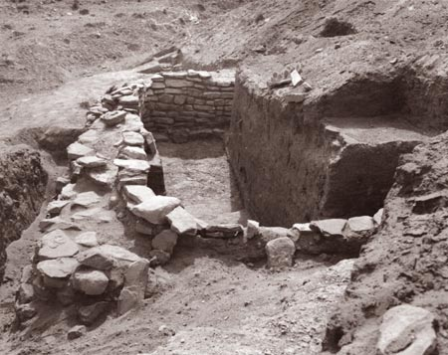

Mormons were the first to use irrigation in the American West. It helped with increasing population because many people went to Dam City Creek in Salt Lake Valley for the overflowing waters so they could be provided with softened soil. In the 1880’s, private companies would try to set up similar irrigation camps such as the Mormons had previously done while also increasing the amount of land being irrigated (1). In 1902, the US Congress passed the Federal Reclamation Act which was for “irrigation works for the storage, diversion, and development of waters” (3). This act included a total of 16 western states such as Arizona, Colorado, New Mexico, Washington, Idaho and more. The Act required that water users repay construction costs from which they received benefits. By 1907, there had been 24 authorized. Reclamation Projects successfully done (3). More and more farmers and settlers started to becomes extremely fond of the irrigation system and it grew very rapidly.

With irrigation developing, World War II began to establish in the same time frame. A quote from the National Park Service website states, “In the frenzy following the December 7, 1941, attack on Pearl Harbor, the federal Government relocated 120,000 persons of Japanese and Japanese American ancestry from the West Coast to 10 inland interment centers…. While there, internees worked on Reclamation projects, building canals and ditches to irrigate their own fields and to help the war effort,” (3). The picture below shows an internment camp in Idaho that was used for relocated Japanese people.

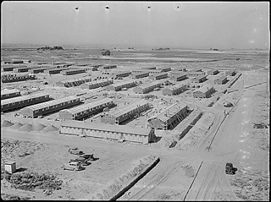

Some states have established laws protecting water usage for irrigation. Utah, for example, has the Utah Division of Water Rights which is a state agency that regulates appropriation and distributions of water in Utah. A “water-right” is defined by the Utah state as the right to take water away from its natural source in order to use for beneficial purposes (2). Since we live in the beautiful state of Idaho, Idaho’s state legislature states in accordance to public waters as, “The constitution and statutes of the State of Idaho declare all the waters of the state, when flowing in their natural channels, including the waters of all natural springs and lakes within the boundaries of the state, and ground waters of the state, to be public waters,” (4).

In terms of recent irrigation news of the American West, there has been some cases of major droughts. A drought is when there is a very little precipitation rate and this will obviously decrease the success rate for irrigation because of the fact that it stems from things such as natural rainfall in streams or river. Being state neighbors with California, almost everyone has heard about the drought they have been experiencing. The state has done many things in order to help replenish the amount of water that they lost like asking residents to cut back on water usage, offering residents money is they choose to get rid of their grass on their properties and more. With the new year starting off with many rainfalls, they are still severely in debt of water (5). The picture below show the dramatic difference of water loss California has experience from just 2011-2014.

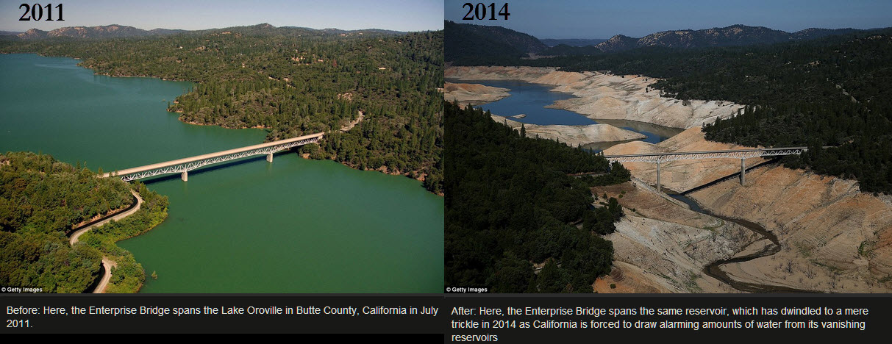

In order to still grow crops, farmers had to change their ways of feeding to match with the small amount of water they were able to receive. “Farms also have adopted more efficient water management technologies and practices, such as drip irrigation, and switching from lower to higher-value crops – helping boost revenue within the limits of available water,” (4). With these new advancements, California’s revenue has remained at a very high and unexpected success.

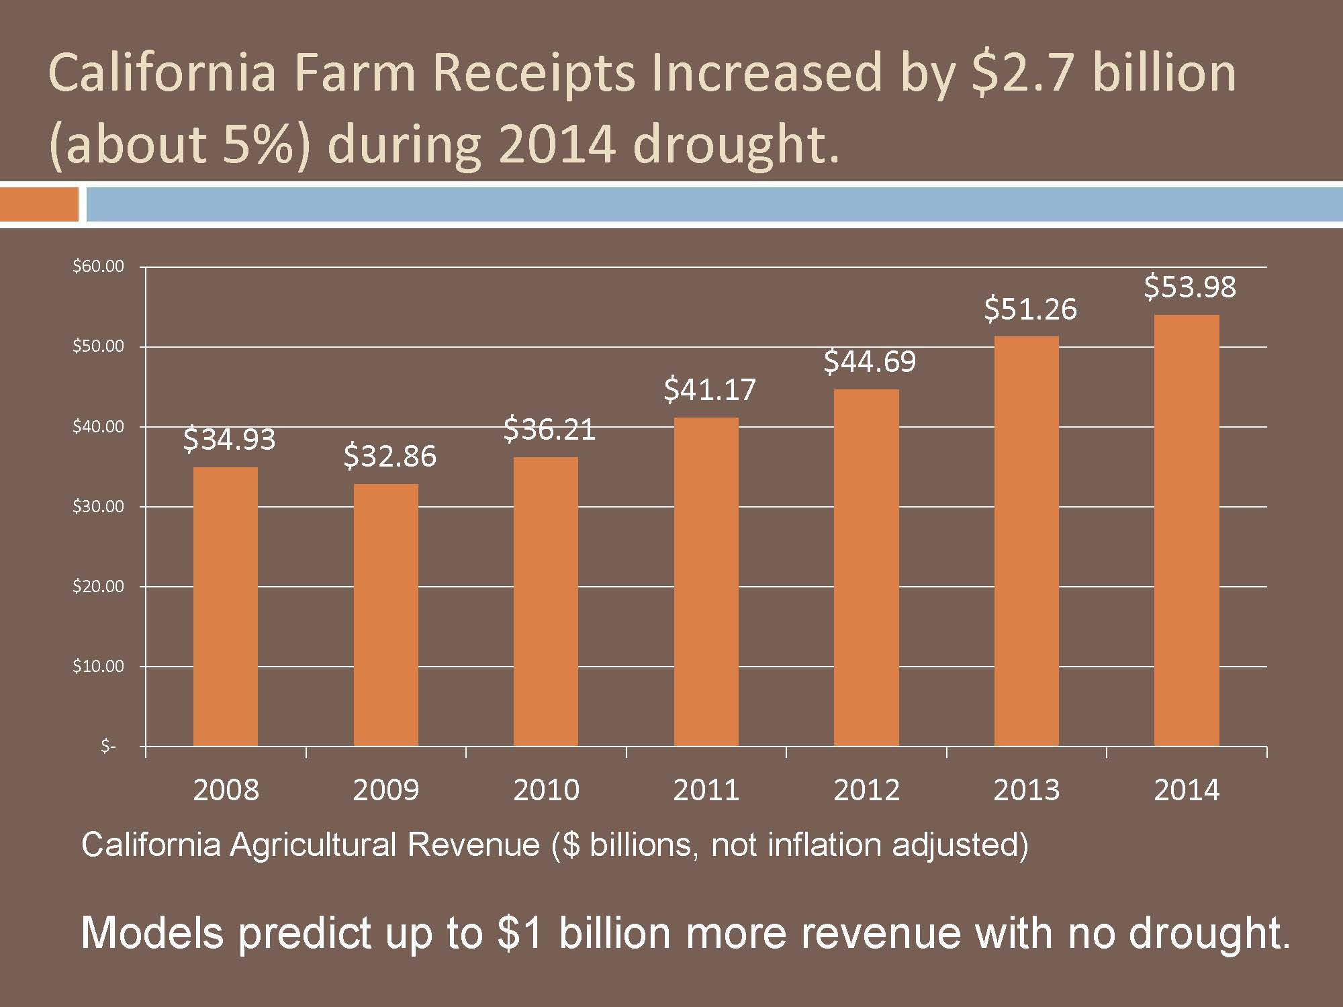

Irrigation is absolutely crucial to life in terms of transportations by the water and more so for growing plants and crops for profits of money and food. When droughts occur, irrigation is nearly impossible, but it is possible with inventions such as the drip system that California used. Irrigation began hundreds of years ago and its unbelievable to see the transformations and advancements that there had been from just a rock wall built around a hole that was made to catch streaming water, to now fields of organized crops with underground water systems and drip systems to help use the most of the water that is given. With how successful irrigation is and how crucial and important it is to life here in America, I do not foresee it stopping or being replaced for a very long time, if not at all. Below is a picture used to show an example of drip irrigation. You will realize that you see these fairly everywhere. “It works by exposing the roots to a direct supply of water. This method is facilitated by the use of drip emitters, which release water in a slow and steady fashion. Drip emitters are small -- approximately the size of a quarter -- and are located on the ground, usually arranged in rows,” (6).

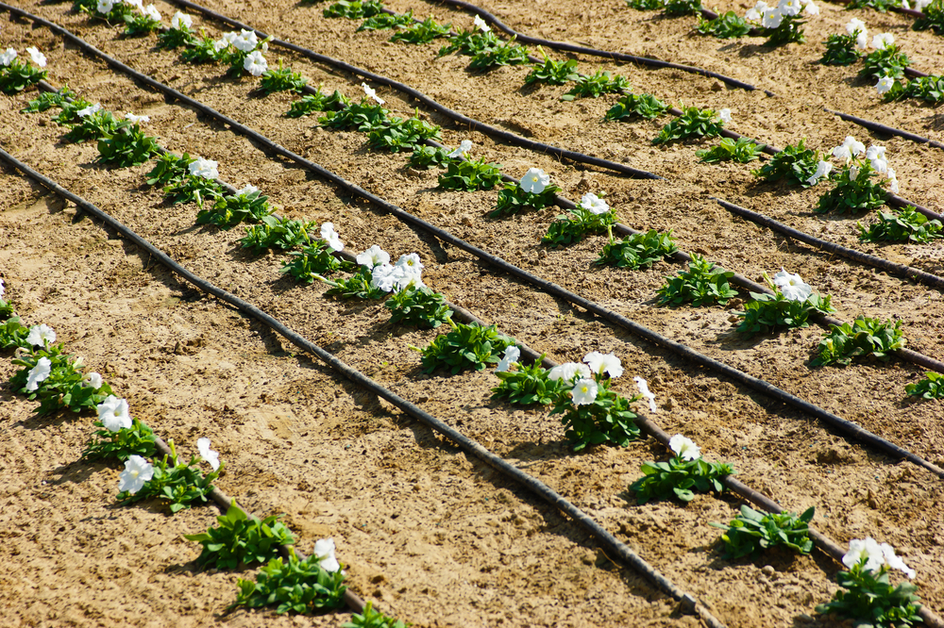(9)

Work Cited

1. “Utah State History.” *Water: Irrigation.* Web. 02 Apr. 2016. Retrieved from ilovehistory.utah.gov/topics/water/irrigation.html
2. "Water Rights." *Water Rights*. 19 July 2011. Web. 02 Apr. 2016.
3. United States. National Park Service. "Water in the West ---Bureau of Reclamation Historic Dams, Irrigation Projects, and Powerplants--Managing Water in the West." *National Parks Service*. U.S. Department of the Interior. Web. 02 Apr. 2016.
4. "Department Of Water Resources." Web. 02 Apr. 2016.
5. "When Will California’s Drought End?" *KQED Science*. Web. 02 Apr. 2016.
6. "How Does Drip Irrigation Work?" *HowStuffWorks*. 2011. Web. 02 Apr. 2016.
7. "The Water Movement." *The Water Movement*. Web. 02 Apr. 2016.