Going down to the river on a warm, sunny day and spending time with family is always a fun activity. There’s so much to do at the river with the family, such as fish, swim, and have a picnic. But, what makes this activity possible? If the water levels at the river were too high, then taking the family there would be dangerous. It wouldn’t be enjoyable to go to a supposed “river” that was basically dried up either. There would be no wildlife around to enjoy. While water management can be a controversial topic**,** engineering is essential in the management of water because it makes sure the rivers stay at an adequate, safe level, it provides reserves in case of droughts, and it is a source of energy for public use.

Water is something everyone and everything needs, but having too much or too little can be an enormous detriment. The problem of having a river overflow in flooding season or having a river become dry in a drought has been present since before the American Indians settled the North American continent.

The American west is known for its lack of precipitation, and therefore there became a dire need for dams. Native Americans were the ones to first create canal systems in the North American Continent, according to the National Park Service. As the generations passed, the Native American Indians began to develop their canal system into dikes, which can be a wall or ditch to stop water. The reason that the Indians started these systems was in order to cultivate and water their fields. In the 17th and 18th centuries, the Spanish came to the New World and worked with the Indians to help improve their water systems. This resulted in the building of dams made of rock and earthen reservoirs. As an added benefit, dams help to keep water at safe levels for both wildlife and humans.

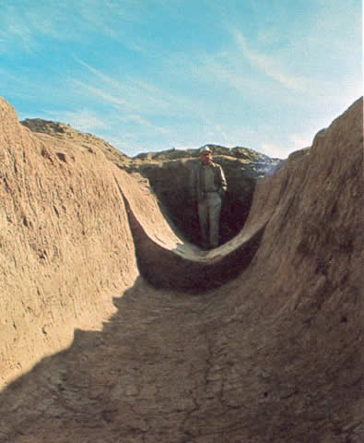 This picture shows a canal created by the Hohokam Indians, who used the canal systems. The Hohokam Indians were some of the first to engineer a way for water to be diverted to their crops and villages. Hohokam water systems were made up of a series of canals, all ranging in size. It would start off with the largest canal branching off from the river, in order to divert a large amount of water. From that, smaller canals would branch off to disperse the water needed. Eventually when the water arrived at the crops, the canals were at their smallest. To control how much water was allowed to go into each field or crop, the Hohokams used diversion gates. It was necessary to be able to regulate the water level in order to ensure that their fields could survive.

1. Jerry B. Howard, "Archaeologist Emil Haury standing in an excavated Hohokam canal," WaterHistory.org, accessed May 5, 2016, <http://www.waterhistory.org/histories/hohokam2/>.

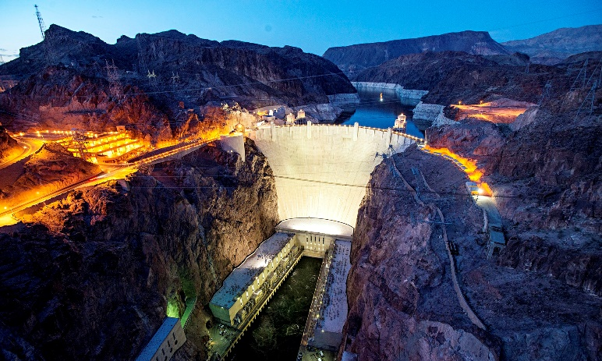 Another way engineering the management of water is beneficial is that it helps provide water in times of drought. A dam is able to contain water from the snow runoff in the mountains. This is an excellent way to store water for times when water is scarcer. The Hoover Dam is a great example of a dam that can store vast amounts of water. California has been having a drought since 2011, according to Todd Frankel who wrote an article for *The Guardian.* The Hoover Dam has helped with some of the relief from the Californian drought, and is considered an “engineering marvel”.

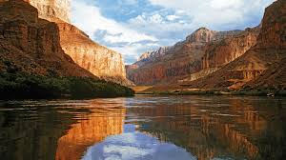2. Todd C. Frankel, "Drought-related reductions in water levels have led engineers to install more efficient turbines at the Hoover Dam," The Guardian, 2015, accessed May 5, 2016

The Colorado River provides a way for energy to be created, but this is only possible with engineering of water. Without brilliant engineers to construct the plans for turbines and generators in order to direct and control the water, families would have less power and no reserves in case of droughts. 3. Naomi Bilia, "Colorado River," Feelgrafix, 2015, accessed May 5, 2016, http://feelgrafix.com/929327-colorado-river.html.

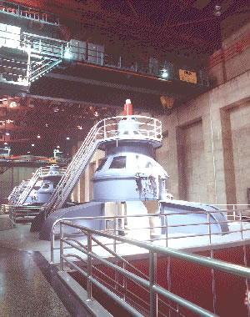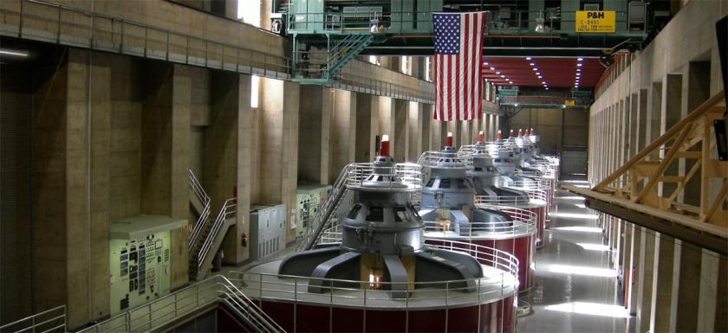Lastly, engineering of water is helpful in contributing to the power supply. Water is an excellent source of power, and the Hoover Dam is another viable example for this. Engineers of this dam designed it with the intent to not only maintain adequate water levels, but also generate energy for others to use. According to the U.S. Department of the Interior, the Hoover Dam has seventeen main turbines. In order for the water to reach the turbines and produce power, it passes through the wicket gates. 4. Cobolhacker/Wikimedia Commons, "Generators at Hoover Dam," Union of Concerned Scientists, accessed May 5, 2016, http://www.ucsusa.org/clean_energy/our-energy-choices/renewable-energy/how-hydroelectric-energy.html#.Vyv4m_krK00.

The movement of the water through the turbines, turns the wheel of the turbines which have magnetics rubbing against copper coils. A generator is also connected to the turbine, and energy is created and stored. This process takes place and creates about four billion kilowatt-hours of hydroelectric power per year, according to the U.S. Bureau of Reclamation. This energy can be used to light offices, buildings, and homes for many Americans. 5. Lower Colorado Regional Photo Lab, "View of generators on Arizona side of power plant," Bureau of Reclamation, 2015.

In conclusion, engineering is essential in the management of water because it makes sure the rivers stay at an adequate, safe level; it provides reserves in case of droughts; and it is a source of energy for public use. While some think dams and reservoirs are harmful to the environment and wildlife, in all reality they are very beneficial to society. By keeping waters at safe levels, flooding is prevented. Stored water provides wildlife with hydration in times of drought. And lastly, water converted to energy is helpful in creating clean energy for American families to use. The engineering of water management has a unique history through the past and will continue to shape our future.

Bibliography

Bilia, Naomi. "Colorado River." *Feelgrafix*. 2015. Travel. Accessed May 5, 2016. http://feelgrafix.com/929327-colorado-river.html.

Cobolhacker/Wikimedia Commons. "Generators at Hoover Dam." *Union of Concerned Scientists*. Accessed May 5, 2016. <http://www.ucsusa.org/clean_energy/our-energy-choices/renewable-energy/how-hydroelectric-energy.html#.Vyv4m_krK00>.

Frankel, Todd C. "US Drought Takes Its Toll on Clean Energy Production." The Guardian. Last modified April 28, 2015. http://www.theguardian.com/environment/2015/apr/28/us-drought-california-hydropwer-hoover-dam.

Frankel, Todd C. "Drought-related reductions in water levels have led engineers to install more efficient turbines at the Hoover Dam." *The Guardian*. 2015. Accessed May 5, 2016.

Gleick, Peter H. "The Past and Future of California's Water." Scientific American. Last modified July 14, 2014. http://www.scientificamerican.com/article/the-past-and-future-of-california-s-water/?shunter=1461161356303.

"Hoover Dam." Bureau of Reclamation. Accessed May 5, 2016. http://www.usbr.gov/lc/hooverdam/faqs/powerfaq.html.

Howard, Jerry B. "Hohokam Legacy: Desert Canals." WaterHistory.org. Accessed May 5, 2016. http://www.waterhistory.org/histories/hohokam2/.

Howard, Jerry B. "Archaeologist Emil Haury standing in an excavated Hohokam canal."*WaterHistory.org*. Accessed May 5, 2016. http://www.waterhistory.org/histories/hohokam2/.

Lower Colorado Regional Photo Lab. "View of generators on Arizona side of power plant."*Bureau of Reclamation*. 2015. Power Plant. http://www.usbr.gov/lc/hooverdam/gallery/pwrplant.html.

"Role of Dams: Why do we need dams?" International Commission on Large Dams. Accessed May 5, 2016. http://www.icold-cigb.org/GB/Dams/role_of_dams.asp.

U.S. National Park Service. "Water in the West." U.S. National Park Service: U.S. Department of the Interior. Accessed May 5, 2016. https://www.nps.gov/nr/travel/ReclamationDamsIrrigationProjectsAndPowerplants/water_in_the_west.html.

"Water in the U.S. American West: 150 Years of Adaptive Strategies." Building Strong Collaborative Relationships: IWR and USACE. Last modified March 2012. http://www.building-collaboration-for-water.org/documents/wwfh20amwest%20full2.28lr.pdf.